Learnings on a Collective Work Rooted in Justice

The Blueprint from the Decolonising the Digital Rights Field in Europe Process

Table of Contents
Introduction 3
10 key learnings from our process 5
Our process journey: the highlights 9
1. Emerging idea and scoping phase 9
2. Collective design phase 9
2.1 Learning from process shortcomings 9
2.2 Halting the process, consulting, and reflecting on what needs to change 12
2.3 Meeting in person: Building a community and writing a programme for a new ecosystem 14
2.4 Putting the programme together and building further connections 15
3. Preparing the implementation and transition phases 16
Our process journey: the full story 18
1. Building a process rooted in iteration, needs, and collective care 18
1.1 Our founding beliefs 18
1.2 The roles we imagined 19
1.3 Thinking in phases 20
2. Moving through the phases 20
2.1 Phase I: Scoping Phase – Holding conversations with organisations, researchers and activists and imagining the process, March 2020 – February 2021 20
2.2. Phase II: Collective Design Phase – Collectively imagining how to bring about structural change, June 2021 to August 2023 21
2.3 Phase III: Implementing the programme and transitioning to a new organisational structure 35
Focus on shared leadership: how the shared leadership was organised 37
Focus on whiteness: What does it mean to grapple with whiteness in a decolonising process? 40
Looking back together: collective reflection on the process 43
Afterword 51
Annexes 54
Graphic Recordings 54

Introduction
Laurence Meyer

For more than three years, we have been engaged in a process referred to as "Decolonising Digital Rights Field in Europe." The name is a mouthful. It is used to designate an endeavour that involves multiple people, as you will come to understand in this blueprint.
The process titled "Decolonising the Digital Rights Field in Europe" seeks to bring about a transformative shift within the current digital activism ecosystem by creating room for anti-colonial digital imaginations.
This blueprint is a capsule capturing various aspects of a fluid process that involved both gratifying victories and frustrating challenges. The goal of this blueprint is to share our learnings and reflections to support future community-driven efforts in the pursuit of justice. It consists of three distinct phases: a scoping phase meant to delve deeper into the original hypotheses underlying this process, a design phase aimed at building upon these reflections and proposing programmatic pathways forward, and an implementation phase centred on ensuring structural changes are put in motion.

The focus of this blueprint is the creation of a programme for change: phase II. During this phase, we created a decolonising programme for the digital rights field in Europe. The goal was to support a field that would prioritise the needs, vision, and interests of communities most affected by technological harm: racialised, queer, poor, migrant, disabled, and gender-minoritised communities.

Video: “Why a decolonising process for the digital rights field in Europe?”

This idea, which owes a lot to Nani Jansen-Reventlow, former founding director of the Digital Freedom Fund, was to create a process that varied from the usual non-profit approach. Rather than producing a programme that simply made small changes to who has a seat at the table, the process meant to address underlying structural issues and question why there is a table in the first place and who decided it was the best mode of gathering. To achieve this, with a wide range of people coming from different perspective, a collective process was needed. Such a process, we believed, would allow us to fully recognise the table as obsolete and explore alternative, better tools, such as pillows, long-chairs, and highchairs…

The assumption wasn´t only that another type of process- diverging from the usual methods put in place in the non-profit sector - would lead to different results. The assumption was also that it would impact fundamentally what we perceived as results. The organisation and configuration of physical spaces deeply influence our thoughts and behaviours. Colonisation, in its different tentacles, involved/involves violent restructuring of spaces, resulting in the creation of new meanings, relationships, hierarchies and functions. It fundamentally altered our interactions with each other, other conscious beings, and the land itself. This was achieved and remains empowered through the occupation and extensive exploitation of lands, the displacement and exploitation of people, and the deliberate erasure of cultural practices including language, arts, religions, and agriculture. To be able to collectively imagine something that could even begin to address these harms, designing new spaces is essential. As such, the process was as important as the programme.

But as we were trying to plan for this collective process – making different organisations and individuals work together for more than a year on imagining ways to change a field of work – there weren’t a lot of resources easily available. It was hard to find how-to guides with examples of structures, advice, learnings, the different types of role etc.

It was not because many before had not undertaken more ambitious collective processes. Anti-colonial struggles are rich in examples of collective imagining of new futures beyond those imposed on colonised subjects. From Bissau to Vanuatu, via Guyana, Brazil and the Garhwal hills. there exist many instances of movements which utilised collective processes to bring about change.

This scarcity of information does not reflect how many transformative collective initiatives have taken place, but rather the unequal representation of such information on and offline.

Therefore, this blueprint aims to provide insights into the design, evolution, and motivations behind the Decolonising Digital Rights Field in Europe initiative to truly examine how and why it changed, what we learned along the way, and what we would do differently in the future. The intention here is not to claim originality or to have found new solutions, but rather to acknowledge that much of the learnings presented here were received from organisers in various contexts, which shaped the course of this specific undertaking.

The process had the goal to design a programme. This document therefore also functions as an accountability exercise towards the movements and communities this programme seeks to serve. There is no black box – here is how the sausage was made.

Finally, it is about staying true to the idea that the process is as important, if not more important, than any result that presided at its inception. Though this process was not perfect, it did bring us a lot. Hopefully, it will inspire others to go on a similar journey and help those who may have similar plans.

To put together this blueprint, we again relied on collective work: Esra Tat and Abby Oulton helped us collect feedback from participants, Alice Z. Jones captured the reflection of others on camera and created the visual identity for Weaving Liberation and the blueprint, Ahmed Isam Aldin produced a video game inspired by the process, Claire Zaniolo did the graphic design of this document, Tessa Curran designed diagrams, Denzel Russel worked as a copy-editor and Kruthika N.S made the illustrations.

Many thanks to Salmana Ahmed, Nadia Benaissa, Myriam Douo, Claire Fernandez, Chris Jones, Ali Khan, Asja Lazarević, Raegan MacDonald, Luca Stevenson, Cianán Russell, Esra Özkan, Alyna Smith, and Asli Telli for the feedback they provided through a survey and/or via a filmed interview.

We hope it serves.

10 key learnings from our process

The key learnings we share below are a mix of observations that participants and coordinators of the process made, which we tried to synthesise around a set of principles. There are certain elements we wish we had implemented in the process, and now in hindsight, we can see how they could have been more effective. These ideas can be found throughout the blueprint with more context as to how they apply, in our experience, to collaborative work that takes racial justice at heart.

⦁ Relationship-and-trust-building

At the core of any process of change that is collective and tries to stand against oppressive structures, relationship and trust building are essential. Tackling structural issues is overwhelming. It feels like too big a task and impossible to achieve at first glance. We are often excellent at seeing the problems, but examples of spaces and practices for imagining transformative solutions – that really tackle the roots of the problems – are hard to identify and imagine. This is often by design – the ‘otherwise’ is often inaccessible so that alternatives to this reality seem unthinkable. Therefore, creating spaces focused on solutions and avenues diverging from ‘business as usual’ demands a great deal of trust and conviction.

Investing in relationship-building in the beginning as a goal in and of itself is crucial. This will allow for new dynamics to emerge. This means, for example, utilising smaller working groups to foster closer bonds, addressing dynamics instead of ignoring them (are there often some people who don´t share their opinions? Are those silences reflecting power dynamics in the society?), creating spaces to talk about the process instead of talking about the content, understanding where are people speaking from and why they want to be part of the collective work etc. In-person meetings with all participants or within working groups are also important to build and nurture relationships, especially considering the challenges of virtual collaboration. Relationship-building should be a core principle, particularly during the initial phase. If we were to organise the process again today, we would make sure to create space for people to get to know each other first and build trust in a more relaxing environment.

⦁ Basic alignment on values

At the start of collective work that aims for radical change, alignment on values is key. This means taking time to unpack central working concepts and set shared definitions and creating space to understand one another’s activist practices. If we were to organise the process now, we would start with an exercise centred around “What does decolonising mean to us” earlier than we did.

⦁ Flexibility in the process

An element that enabled this process to work was flexibility, both in terms of time and structure. If necessary, the process should continue beyond the initial timeline to evaluate criticisms, give participants more space for their collective work, include a consultation process etc. It is important to depart from false feelings of urgency that stem from the belief that effectiveness is measured in how quickly things are delivered or how deadlines are met. Inflexible timelines have exclusionary effects. It excludes under-resourced organisations that are already overworked, individuals dealing with mental health issues and caregivers in general who have multiple days in one. Putting pressure on time favours people who have available time due to the shape of their schedules. In the structure, flexibility can be accomplished through a willingness to completely reshape the agenda when needed, to address significant criticisms raised, or in the event a harmful incident occurs as well as simply create multiple ways for people to share inputs and be present.

⦁ Queer, racialised, disabled, migrant, gender minorities, poor communities at the centre

In any collective work that embraces a justice framework and acknowledges the colonial dynamics at play in the oppression it aims to tackle, it is essential to ensure that the process centres the people that are most affected, inversing the usual compass. For this to happen, one necessary but not sufficient condition is to mitigate the impact of oppression in the workplace by providing a stipend, collective and individual mental health care, childcare support, etc.
This includes acknowledging the racial, class, and gender context in which participants are involved in the process and assigning concrete measures addressing aftercare (which we overlooked) and visa apartheid. Acknowledging power dynamics will create a space to foster open communication.

Many participants in this process would have welcomed even more presence and leadership in the working groups from members of communities most impacted by systemic oppression. They also acknowledged the disproportionate burdens and risks borne by marginalised communities in driving social change. Recognising that these tensions cannot be resolved without large-scale systemic change, the group(s) should consider alternative methods to support and better care for one another, especially for those most affected, while also advancing towards their goals.

⦁ Care

Care is a central aspect of collective processes that strive for justice. It is closely linked to the question of flexibility, where both the process facilitators and the group as a collective are prepared to change plans entirely to prioritise the wellbeing of the group and create space for healing. This care is particularly crucial for members of the group who exist at the intersections of racial, gendered, and other oppression, as decolonising work triggers racial trauma. We would now also add more continuous collective care support and aftercare options. It is crucial to prioritise the needs and experiences of the collective over the pressure to be productive.

⦁ Ongoing learning and unlearning

Progressive unlearning is important for the design and content of the process. One of the key objectives of such processes is to create a space that allows for a different approach, making the necessary change palpable. This entails a lot of unlearning, such as re-evaluating what it means to act professionally, while also embracing liberatory practices. Decentralised and emergent ways of collaborating are unfamiliar to many, so creating space to explore the questions that arose and the doubts and meet with organisations and collectives who have found answers to those questions allow things to go forward. Creating spaces for learning and unlearning along the way is also a way to build trust among the group. During the decolonising process we had peer-learning sessions as well as workshops during the plenaries and a white community of practice.

⦁ Artistic practices, joy and imagining

Artistic practices that create space for dreaming and visions of alternative futures can bring joy into the process. Investing in joy and pleasure is essential to enable transformative thinking, to arrive at a place where imagining a better future is more attainable. This is particularly crucial when addressing challenging topics. Following the initial plenary, artistic support was hired, and later, an artistic advisor joined the team. Both greatly contributed valuable artistic dimensions to the process. The plenaries and meetings that followed included sessions on collective painting, t-shirt making, shared rituals, group creative writing, and other creative activities.

⦁ Simple and multiple ways of sharing information

Creating multiple ways of sharing information is essential to ensure that different forms of digesting information and producing knowledge are respected.
Instead of long text-based documents outlining the intended structure of the process for the participants at the outset, better to have a shorter document (2-3 pages) using illustrations and diagrams, alongside an audio version.
To ensure that information is properly shared, it is necessary to use various media. Thanks to the criticism shared by participants at the second plenary meeting, we realised that our heavy focus on the written word can be exclusionary and reproduce white supremacy culture. Following this feedback, we have worked to increase our use of visual and audio methods of sharing information. We also organised drop-in sessions where participants could ask questions and be presented with the information they required in a spoken format.

⦁ Generative conflict

When a conflict arises, it is important to not disregard or minimise it, but to instead halt things and thoroughly examine how the conflict emerged. The urge to always have a peaceful and civil process can also serve as a tool to maintain oppressive dynamics, whether those dynamics are intentional or not.

A frontal challenge might indicate many issues, ranging from the importance of providing mental health support available for individuals to a complete redesign of the organisational structure. At the very least, challenges highlight misalignments between participants or overlooked problems in the design.

⦁ Shared leadership

Shared leadership can foster more radical processes by sharing the risks of failure, enabling bolder actions, and offering a space to dream together, as well as complementing each other’s skill sets and perspectives. Additionally, shared leadership creates a centre of care and support among leaders, creating a ripple effect that is felt by all participants in the process.
The process has been anchored in the shared leadership of Laurence Meyer and Sarah Chander, who led the process as part of their respective roles at DFF and EDRi. The shared leadership model departs from dominant notions that a single individual should have sole responsibility for a project.

Our process journey: the highlights

What you will read below is a condensed overview of how the process was built, how it was implemented, and what we learned from it. To read the full version, scroll down to page 18.

1. Emerging idea and scoping phase

One of the catalysts for the decolonising the digital rights field in Europe was sparked by a simple realisation from Nani Jansen Reventlow, former executive director at Digital Freedom Fund: she was the ONLY Black woman in the room in almost all digital rights meetings.

The idea of a decolonising process, rather than a simple diversity and inclusion review, came from not being satisfied with just having more people of colour in the picture. The aim of the process is to fundamentally change the structural framework that prevents communities who are most affected by technological harm from leading the work on campaigning, organising and litigating against it.

The process started by engaging in conversations with different racial, social, and economic justice organisations and digital rights organisations. We looked to their experience to understand the current challenges in the field and identify our steps moving forward. This ended up constituting phase I of the process – the scoping phase.

2. Collective design phase

2.1 Learning from process shortcomings

During the first phase, an idea emerged to collectively write a programme with steps to create a transformative digital rights field. The collective design of this programme would thus become phase II of the decolonising process.

The key questions behind the programme design were as follows:

⦁ What are the issues with the current field?
⦁ What type of field do we imagine instead?
⦁ Which activities, spaces, and resources do we create to get to the field we imagine?

A group of 30 individuals with diverse backgrounds in digital rights, racial justice, social justice, and economic justice, as well as funders, participated in the programme design phase. Some of them had previously participated in phase 1, while others were new to the process.

We had envisaged a structure around 4 plenary meetings that would punctuate the ongoing work

The participants were divided into working groups: programmatic, funding, public engagement, collaboration, and organisational. Each participant was offered a stipend of 500 euros for each of the phases of the design process that they could choose to receive themselves or to donate to an organisation. A minority of participants, primarily those who participated in the process as part of a paid role at an organisation, chose not to receive a stipend.

During the second plenary, a participant developed a series of important criticisms of the process. These criticisms revolved around several concerns: the limited timeline, the lack of guidance given to working groups, high expectations, and the reliance on written communication among unfamiliar individuals, which made things overwhelming. All of these aspects created a sense of extraction and seemed to reproduce problematic dynamics.

Indeed, the initial process design had multiple shortcomings.

First, most of the participants did not know each other and came from very different practices and areas of activism. They also had different motivations to join the process.

Second, the participants had very busy schedules and were focused on their own professional and personal priorities. Carving out time to plan for meetings was a challenging task, let alone attending them. In addition, the design process began at a point where people had already dedicated over one year to working through online meetings, and many people were burnt out by the increased work intensity and lack of human contact inherent within this method of operation.

During the design phase, we made several assumptions, one of which was that people were not only comfortable using the theory of change format but also found it useful.

These factors frequently led to people of colour in the group either shouldering a disproportionate share of the burden or, in many cases, completely disengaging from the process, especially when they also belonged to smaller antiracist and/or feminist organisations.

If we were to organise the process again today, our priority would be to create a space where people have the opportunity to get to know each other and build trust before moving forward. In addition, we would organise online meeting slots for the working groups to come together to alleviate the logistical burden on the participants.

Learning: conflicts are key to transformation

We have learned that when a conflict arises, it is important to not disregard or minimise it but rather to halt things and thoroughly examine how the conflict emerged. The urge to always have a peaceful and civil process can also serve as a tool to maintain oppressive dynamics, whether those dynamics are intentional or not.

It is crucial to learn how to effectively prepare for and manage conflicts without alienating or exhausting those involved in the discussion and organisation of a space.
This is one of our biggest learnings and one skill we wish we had had more knowledge and practise on.
Creating space for conflicts in a work context also challenges the notion of “professionalism,” which is deeply embedded in white supremacy and ableism. Who can afford to always stay calm but the ones for whom the system has been designed to function?

While not every conflict requires a halt, we have learned that when the subject touches on the fundamental way of functioning a collective process, a need arises to address the underlying issues.

2.2 Halting the process, consulting, and reflecting on what needs to change
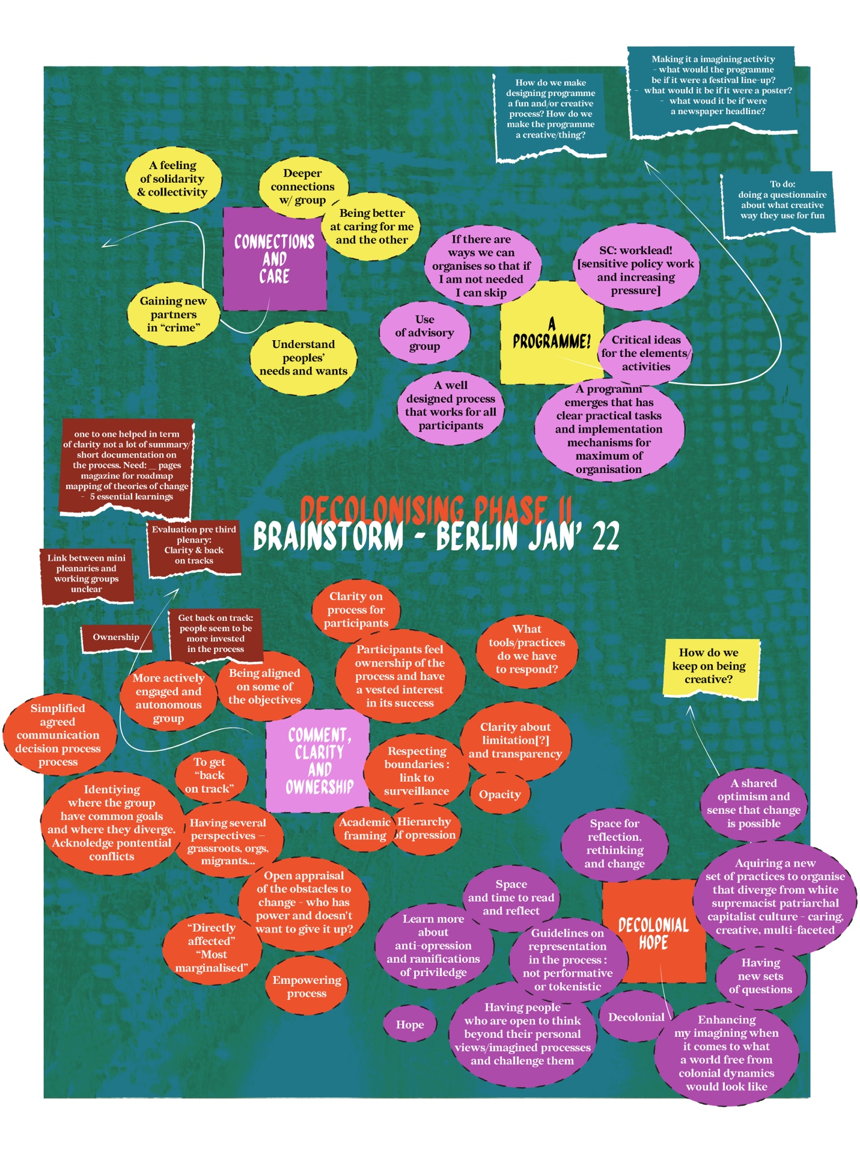
“What are your desires for the process?”: Visualisation of a team brainstorm, January 2022

Following the second plenary, we decided to pause the process and take the time to reflect on its structure and organise consultations with the participants on how to move forward. In addition, as organisers, we looked for community care support to help us process the impact of the second plenary and the criticisms raised during it.

We put in place a series of drop-in sessions where the participants were free to come in and discuss what they would like to see happen in the process. Additionally, we also gave the option to give feedback via voice notes.
We had consultation calls with experts in transformative processes and, as organisers, we held in-person brainstorming sessions.
We developed a new proposition for the second phase and individually discussed it with each participant in one-to-one conversations led by Sarah and Laurence, who were both co-leads of the process. These discussions were important for understanding participants’ perceptions of the process and their desires and goals. These were aspects that we had not thoroughly discussed before.

Some participants disengaged completely from the process following the second plenary.

Following the one-to-one conversations, a new formula was adopted for the process.

The new formula introduced a series of online sessions every two weeks, alternating between working group sessions and peer-learning sessions.

During the working group sessions, each working group could collaborate without the need to schedule this for themselves. These slots also gave the working groups an opportunity to ask any questions they had or share any feedback regarding the process with the organisers. In addition, the organisers used these spaces to give the working groups more input to help shape the way they worked together and encourage creativity. For instance, one session focused on creative writing to imagine alternative futures and included an introduction to afrofuturism.

During the peer-learning sessions, experts would share their knowledge on a topic relevant to the process in an informal discussion format.
Attempting to organise the process as a learning space also requires us to tackle some aspects of value and extractivism inherent to any work relations in our current system. The workplace is often a space in which we expect to know instead of to learn, to give instead of to receive. Individuals are supposed to be compensated fairly through wages. This narrative fails to consider the fact that many of us are able to learn in the workplace due to the care work provided by others in our personal and professional lives, which in part liberates extra time and mental space. It concerns domestic work, paid or unpaid and emotional support. These dynamics are influenced by social class, gender, and race and intersect with ableism to impact our economic agency. Therefore, the disability justice movement often invites us to ask whose needs are met, instead of who needs extra care.

The topics of the peer-learning sessions were Trauma-Informed Organising, Anticolonial Tech and Visions from the Global South, Anticolonial Practices and Anticolonial Leadership, and one entitled The Revolution will not be Funded, in reference to the INCITE! Essay.

At this point, it became clear that establishing in-person connection was crucial to truly foster trust, community-building, and allowing the work to move forward.

2.3 Meeting in person: Building a community and writing a programme for a new ecosystem

We held our third plenary together in Chivasso, Italy, to continue reflecting on activities for the programme.

At the plenary, we created an open space for participants to bring the topics they wanted to discuss, based on questions and ideas that had arisen thus far in the process. The topics discussed included decolonising as a process, anticapitalism and technologies, identity politics and collective liberation, reparations and healing, decolonising evaluation frameworks, accountability in an anticolonial organisation, exploring funding dynamics and envisioning alternative models. The open sessions concluded with an exercise of mapping what decolonising means to us, as a way of bringing together many of the ideas raised in the different discussions.

Video: "What decolonising means to us"

Learning: Organising with joy

Joy and creativity are essential in collective processes that aim to tackle oppression and create liberation. When planning for the plenary in Chivasso, our intention was to create as much space as possible, as we understood that the challenging topics discussed required an environment for exploration. As a result, we made each session optional and avoided going full speed on the first day. We deliberately integrated time for connections and spaces of joy, allowing people to engage and participate in activities together before having to enter what we knew would often be difficult conversations. Inviting artistic practices and fun into planning and as core activities also helped us to ease into our time together. We held a collaborative painting exercise, went swimming, danced, had an open mic session, and even imagined anti-colonial t-shirt slogans. Once again, Ahmed Isam Aldin played an essential role in providing artistic support.

During the closing discussion in the plenary, a participant made an important suggestion emphasising the need to gather input on our draft from people and communities who were not in the room to ensure that no perspectives were missed. We started looking for funding to organise those consultations once a first draft of the programme was ready.

The process ended up taking longer than originally planned. As organisers and participants, we learned to be comfortable with this and prioritise reflection, iteration, our respective individual and collective care responsibilities, nourishment and meaningful artistic practice.

2.4 Putting the programme together and building further connections

Following the third plenary, collaboration in the working groups continued. Given the significant value that participants expressed for in-person working time, funds were made available for each working group to meet in person between the third and fourth plenaries. In addition, the decision was taken to also hold the fourth and final plenary in person in Essaouira, Morocco.

The plenary lasted a week, deliberately longer than previous meetings in order to enable participants to come together and connect as a group.
We hosted a creative t-shirt customising session, as well as a writing session where we wrote a manifesto for the process – embracing the artistic, political and spiritual invocative power of manifestos. These were moments of creative joy and mutual discovery that allowed us to hear and see each other under new suns.
As the different sessions unfolded, we witnessed the programme unfold before our eyes. The road was full of questions and excitement as we figured out: “How do we ensure the resources really get redistributed?” “How can we mitigate co-optation here?” “How do we recognise and compensate for the work that has already been done?” And most importantly, “How do we not create another mechanism that exhausts or silences radical voices?”. We were at that moment a world within a world, with a particular energy flow that arises when change feels attainable.
A concrete reminder of our commitment to practise our beliefs came in the aftermath of a harmful incident that occurred during this fourth plenary meeting. This called for the prioritisation of community care structures to address the harm and begin healing, even if it caused disruption to the process timeline. Therefore, we reshaped our in-person meeting to respond to the immediate needs of the participants and left the final assembly of the programme for a later online meeting. Here again, we took the decision to alter the agenda to allow space for what was happening and deal with it.

The deeper one immerses themselves in an anti-colonial ethos, the more unbearable the violence of our colonial reality becomes. Truly engaging with anti-colonial dreaming means continually confronting the intolerable aspects of the present time and time again. It also makes it very clear how different everything could be. There are more generous and loving worlds to build. This is a result and a necessary step in such work.

It also requires us to create practices to take care of those emerging emotions, the resulting internal and external conflicts they create, and the new dimensions of colonial collective traumas that must be addressed. At that moment, it was important for us to act in alignment with the programme we were building and to practise what we preach, to the best of our abilities. It became impossible to detach our personal identities from our collective actions. As we were calling to centre community-building in all parts of the programme, we ourselves were going through a crucial community-building moment.

Learning: Building around a violent world

An important learning is that due to the visa-apartheid world we live in, it is extremely difficult to organise events in places where there are low to no visa requirements for people from the global south, especially people from the African continent. Considerations about travel regimes also include bearing in mind the screenings to which transgender people are subjected when travelling and the potential risk of violence they may face in the process.
Another important learning is that when organising gatherings centred on oppression with people that are directly negatively impacted by it and work on it as activists, there is a need for after-care, as well as care during the meeting itself. These times of imagining, dreaming and community are followed by coming back to business as usual.

After a collaborative effort that involved ideas from the different working groups, review by the participants, and even a drafting group among the participants, the organisers arrived at a first draft and the decolonising programme came to be.
We followed the first draft with a consultation process to make the draft programme publicly available and offered stipends to people with crucial perspectives that we felt had been missing in the process.

This first draft of the programme was made available in seven languages, including an audio version, where feedback was gathered in focus groups, one-to-one interviews and through a public survey. The gathered feedback was then shared with the participants in the process as we held a session to identify ways to fill the gaps and address key needs that arose in the consultation.

The organisers of the process are now reworking the draft into a final decolonising programme. We expect it to be ready for publication in autumn 2023.

3. Preparing the implementation and transition phases

Once the decolonising programme is launched, the third and final phase of our current process will open. In this phase, we seek to ensure the sustainability of the work by preparing the conditions for the activities outlined in the programme to be implemented. This will, in many ways, lay the groundwork for future beginnings and imaginations.

What we envisage for this phase is for a collective that emerges from our process to take up the coordination and ownership of the programme moving forward, decentring dominant actors such as DFF and EDRi and allowing for the implementation of the activities proposed. This collective would seek to operate in a transformative way, in accordance with the values and learnings taken from the process.

We are currently working on a plan to smoothly transition the coordination and ownership of the process from DFF and EDRi to this collective. Our goal is for this to be done measuredly to ensure the sustainability of the process.

While the timeline for this part of the process has not yet been finalised, in practice, the process is not linear, and as such, reflection has already been applied to the modalities of this impending transition.
We hope that this new collective and the implementation of the programme will open 2024 with new possibilities for the digital rights field in Europe.

Our process journey: the full story

What you will read below is a more in-depth rendition of our process structure, interspersed with learnings and reflections.

1. Building a process rooted in iteration, needs, and collective care

1.1 Our founding beliefs

In March 2020, the Digital Freedom Fund (DFF) and European Digital Rights (EDRi) embarked on a multi-year process aimed at bringing together communities impacted by digital harm. The goal of this process is to include individuals who have been structurally excluded from the current digital rights field in Europe and to foster connections with existing digital rights actors and organisations that fund digital rights work. The objective of this process was to collectively design a decolonising programme that would radically transform the European digital rights field.

While the collective drafting of the programme was always a central element of this work, the coordination team believed that the process was equally important as the output. As a result, the process was designed to be iterative and flexible, intentionally departing from ‘business as usual’ and making a clear break with ways of being, working and producing that reinforce lineages of oppression.

As such, the initial timeline and structure changed significantly over the course of the process, responding to the input of participants and the requirements of the work. The two main reasons for these changes were:

⦁ Taking consideration of the lived realities of the participants, including care responsibilities, financial precarity, extensive work and activist commitments, and dealing with the private consequences of geopolitical stress. We deliberately departed from an understanding of work performance as being artificially detached from people’s lives.

⦁ Prioritising needs and healing in the face of harm. Some participants in the process faced issues relating to their physical and mental health, as well as serious concerns about safety and security, all stemming from marginalisation in the wider society. We prioritised acknowledging harm and trauma and responding to needs rather than rigidly sticking to a set structure or process that would have added undue hardship in many situations.

By committing to a state of flux, imbued with care for ourselves and each other, we created a space for new processes to emerge from our ongoing reflections. These new processes proved useful for us and invited the very community building moments that made the work possible in the end.

1.2 The roles we imagined

⦁ The process facilitators performed the coordinating work, gathered input from the different working groups, and led the drafting process, the changes to the design phase framework, and all logistical related tasks. They planned the structure of the process, the proposed topics for the mini-plenaries, and worked with the meeting facilitators to plan the agenda of the plenary meetings. They facilitated mini plenary sessions and part of the final plenary. Process facilitators participated in the process as part of their roles as members of staff at DFF and EDRi.

⦁ The core participants dedicated approximately one day per month to the process, undertaking preparatory work for the meetings and participating in meetings and discussions. They proposed activities and topics to include in the decolonising programme and shared the responsibility for making the main decisions concerning its content. The core participants were divided into thematic working groups, each of which developed proposals for the programme. The core participants had the option of receiving an honorarium to recognise their contribution to the process.

⦁ The advisory group had general oversight of the process, assisting in identifying any gaps or omissions. The advisory group members covered a range of relevant expertise for the process but did not play a role in decision-making. The advisory group also had the option of receiving an honorarium to recognise their contribution to the process. This is one of the role that ended up changing the most- with fewer advisories being involved but participating in all activities as part of the core group and sharing knowledge via peer-learning sessions instead of meetings every trimester with all advisory group members.

⦁ The artistic support was responsible for bringing creative, artistic elements into the process, while also documenting it through artistic outputs. They played a key role in planning the plenary meetings and helped organise artistic sessions during those gatherings. Some of these were planned in advance and others occurred spontaneously. The artistic support was paid for his work as a part-time DFF employee.

⦁ The meeting facilitators worked closely with the process facilitators to design the plenary meetings by taking the initial objectives and transforming them into an agenda. They not only facilitated the first three plenary meetings but also contributed to a portion of the final plenary. In addition, they served as an advisory role for the rest of the process, offering advice and suggestions on how to enable effective collaboration between and within the working groups. The meeting facilitators were paid on a consultancy basis for their work.

⦁ The consultation lead was responsible for organising and running the consultation process once the first draft of the programme had been completed. They were also responsible for synthesising its results, sharing them with the core participants for their input, and helping to ensure that the feedback was implemented in the final draft of the programme. The consultation lead was paid on a consultancy basis for her work.

⦁ The artistic advisor was responsible for bringing artistic and creative elements into the process. They facilitated an artistic session at the final plenary and assisted in documenting the process through video recording and editing. This included conducting and recording a series of interviews with participants at the third and fourth plenaries. The artistic advisor was paid on a consultancy basis for her work.

1.3 Thinking in phases

At the beginning of this process, we were confronted with the magnitude of what we wanted to change. Recognising the need for a radical transformation in the field, we understood that this required an understanding of structures of power, collective and transformative change processes, spaces for imagination, and clear processes of design and implementation. When designing this process, the key underlying questions were:

⦁ How to ensure we bring together a balanced group of people with the interest and capacity to transform the digital rights field?
⦁ How to embrace forms of imagining that ensure we can envision transformative change?
⦁ What do we need to do to mitigate the impact of oppressions in the process?
⦁ How do we ensure that our collective vision is collated, captured, and implemented?

There were three main phases to the process, each building upon the previous one. We began each phase with a plan of what we wanted to accomplish, however, as the needs of the participants and unexpected circumstances arose during the work, this plan changed.

⦁ Phase I: Scoping Phase: The first phase of the process dealt with the original idea and scoping and was meant to flesh out the premises of the project together with relevant stakeholders. This lasted for one year.

⦁ Phase II: Collective Design Phase: The second phase of the process was the collective design phase of the decolonising programme, which spanned a little over two years.

⦁ Phase III: Implementation and Transition Phase: The third and final phase of the process is expected to focus on the implementation of the programme and the transition towards a sustainable way of organising to carry this process through to the future.

2. Moving through the phases

2.1 Phase I: Scoping Phase – Holding conversations with organisations, researchers and activists and imagining the process, March 2020 – February 2021

During the Scoping Phase, we began speaking to organisations, collectives and individuals who had prior experiences of decolonising processes or who were involved in addressing issues relating to racial, social and economic justice. Our goal was to explore their understanding of their work to be connected with the digital rights field and gain insights into their experience within the field.

We planned these initial conversations around a mapping of people who we felt would be impacted by this work, those who would be interested in transformative change in digital rights, and those who had the capacity to bring about this change. We conducted over 30 conversations with individuals working “outside” the digital rights field, as well as 20 organisations within the field itself and with philanthropic organisations that provide funding for digital rights work.

We kept a record of the main challenges, concerns, and visions of the people interviewed, always asking ourselves who else should we speak to? This formed an iterative interview process, widening the net of our conversations.

Many people asked, "What is the digital rights field?" This question was a key point of feedback, especially with regard to vocabulary. The other concern was that interviewees found digital rights organisations to be extractive and sometimes paternalistic within their few experiences. Finally, while many recognised the challenges posed by digital technologies, they voiced that they did not have time to deal with it while trying to manage numerous urgent matters with very few resources.

One of the responses to the feedback received in this phase was the creation of the Digital Rights for All project within DFF. This project aims to support racial, social, and economic justice organisations in building their autonomy in relation to tech-related topics and issues.

This scoping phase culminated in an online gathering in December 2020 that brought together 30 interviewees. Following a visioning session that projected us into the future we desire, we began identifying the building blocks for a design process that would enable us to achieve a radical transformation of the digital rights field.

Between the first and second phases, several key events occurred:

⦁ Recruitment of a staff member at the DFF to take on a large part of the operational and strategic leadership of the process;
⦁ Planning of the collaborative design process for a decolonising programme based on the building blocks established during the gathering held following the consultations;
⦁ Fundraising for the design process.

2.2. Phase II: Collective Design Phase – Collectively imagining how to bring about structural change, June 2021 to August 2023

The goal behind the Collective Design Phase was to create a space for connection and inspiration conducive to the design of a decolonising programme for the digital rights field in Europe. Initially planned for one and a half years, this phase ultimately extended beyond two years.

The design phase involved a group of 30 people from digital rights, racial, social, and economic justice backgrounds. Some of them had participated in phase I, whereas others were newcomers. It included three sub-stages, which will be explored below, that resulted in four plenary gatherings and smaller meetings in between.

Each participant was offered a stipend of 500 euros for each of the three sub-stages of the design process and had the option to receive it themselves or to donate to an organisation. A minority of participants, primarily those who participated in the process as part of a paid role at an organisation, chose not to receive a stipend.

The work was primarily conducted through five working groups, each consisting of 5-7 participants. Each working group focused on a particular aspect of how the digital rights field organised its work, including programmatic efforts, funding strategies, public engagement, collaboration and organisational structures. These groups were chosen as a result of input and initial desk research from the scoping phase.

We also initially had an advisory group in which the members also received a stipend. The advisory group was selected on the basis of key needs in the process, including a mixture of thematic knowledge (e.g. anti-colonial, digital rights) and skills (e.g. transformative change processes).

2.2.1. Sub-stages of the collective design phase

We planned three sub-stages: the first stage involved formulating a theory of change, the second stage involved proposing activities, and the third stage was dedicated to refining those activities. Each phase was meant to answer the questions below:

⦁ What are the issues with the current field?
⦁ What type of field do we imagine instead?
⦁ Which activities, spaces, and resources do we create to get to the field we imagine?

Here is how it was planned on paper:

Design Stage 1: Scope Setting and Theory of Change
⦁ Group work to tackle the questions: Which areas will be worked on? What needs to be changed? Who are the key actors who need to be involved?

Design Stage 2: Proposal of Activities
⦁ Group work to research and reflect on activities undertaken in other areas and their effectiveness, as well as to develop our own ideas.

Design Stage 3: Assembly of the Programme
⦁ Group work to set priorities, reflect on how to implement the programme and how it should be monitored and evaluated.

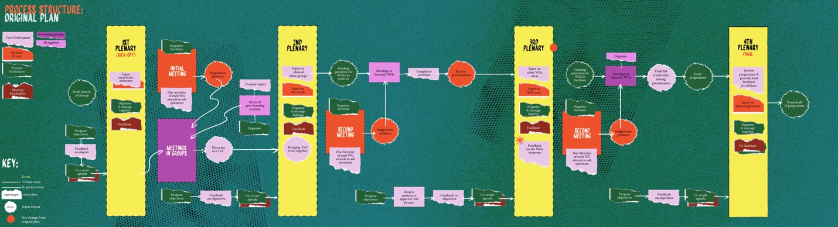
A visualisation of the originally planned structure of the process

Learning: Simple communication of process design
We took a long time to formulate the three questions succinctly (long after the design phase had started), and our titles for the stages did not effectively prioritise simple communication. For a long time, we struggled to explain what would happen during this process and why it was relevant in simple ways. One key learning here is that at the outset of any collaborative work that aims to tackle structural issues, a lot of time needs to be invested in clarity around the definitions, methods, and ensuing goals. How can it be expressed with as little jargon as possible? There is often a simpler way to say things, but it takes time to find it.

For example, instead of relying on a lengthy 30-page document that used language often used in institutional and funding proposals, it would have been better to provide 3 concise pages with illustrations and an audio recording to answer questions.

While we launched the process, we also recruited someone to assist as artistic support. Ahmed Isam Aldin became central to the work by integrating creative practices into the way we worked together, as well as documenting the discussions and process in the form of a video game.

2.2.2 Moving through the sub-stages of the collective design phase

The design phase was an important part of the work. We envisaged the stages as a linear process that would lead us to the development of the activities of the process. In practice, however, the processes of ideation are not linear, and the design phase did not follow the clear stages outlined above. Throughout our journey, we had to reflect, iterate, and divert from our original plan. Here is how the process unfolded in practice.

⦁ Design Stage 1: Identifying the issues and envisioning what type of field we want (former Scope Setting and Theory of Change)

Amid pandemic-related constraints, the early meetings all took place online, including the first plenary meeting during which all participants, the advisory group, and the coordinators of the process convened as a group for the first time.
The initial idea was for plenary meetings to be moments of alignment between different groups.
For the first plenary, for example, staff at DFF and EDRi (the facilitators of the process) worked on a first draft of a theory of change, and the participants had the opportunity to give feedback. The participants also met their working group colleagues for the first time.

Between the first and second plenary, the working groups were meant to find time to meet and work on a theory of change for their thematic area. The plan was for the second plenary to give each group a chance to review the theory of change of the other working groups and for us to explain to the group what was going to happen during the next phase. We also held our second plenary meeting online, with the plan to transition into a propositional phase – namely, the working groups were to consider what type of activities they could envisage for a decolonising programme.

However, during this plenary, one participant formulated a series of important criticisms of the process. These criticisms concerned the very tight timeline of the process, the feeling that the working groups were left to their own devices with insufficient guidance, the expectation to deliver a lot despite the fact that participants barely knew each other, and lastly that all communications were in writing and were quite heavy to digest. All these aspects felt in many ways extractive or seemed to reproduce problematic dynamics.

Learning: Centre connection and reflection on power in organising modes

Indeed, the initial process design had multiple shortcomings.

First, most of the participants did not know each other and came from very different practices and areas of activism. They had different motivations for joining the process, as well as different relationships to colonialism and levels of awareness regarding its impact on their lives.

Second, participants had very busy schedules and their own organisational and personal priorities. It was very difficult to carve out time to plan meetings, never mind actually attending them. In addition, the start of the design process came at a point where people had devoted over one year to working through online meetings, and many people were burnt out by the increased work intensity and lack of human contact inherent within this method of working.

Finally, we made many assumptions in our design of this phase, one of which was that people were not only comfortable using the theory of change format but also found it useful.

These factors frequently led to people of colour in the group either shouldering a disproportionate share of the burden or, in many cases, completely disengaging from the process, especially when they also belonged to smaller antiracist and/or feminist organisations.

If we were to organise the process again today, our priority would be to create a space where people have the opportunity to get to know each other and build trust before moving forward. In addition, we would organise online meeting slots for the working groups to come together to alleviate the logistical burden on the participants.

Tackling structural issues is overwhelming. It feels like too big a task and impossible to achieve at first glance. We are often very good at seeing the problem, but examples of spaces and practices for imagining transformative solutions that really tackle the roots of the problems are difficult to identify and imagine. This is often by design – the ‘otherwise’ is deliberately made inaccessible so that alternatives to this reality appear unthinkable. Therefore, creating spaces focused on solutions and avenues diverging from ‘business as usual’ demands a great deal of trust and conviction.
Carving time to design step-by-step plans to dismantle oppressive structures becomes especially difficult when one is also responsible for supporting people at risk of being deported, addressing cases of gender violence, and navigating complicated personal realities.

Activists often deal with weighty, challenging subjects on a daily basis, and the news typically does not deliver hopeful messages. No one desires another room or space for contemplating the injustices of the world, devoid of any joy or perspective that can offer a way out.

We learned that the following are essential conditions for designing and planning for systemic change:

⦁ Prioritise building relationships and trust among members of the group.
⦁ Break the business-as-usual pattern of working by inviting creativity and playfulness into the process.
⦁ Reduce the logistical burden on those participating in these processes

⦁ Design Stage 2: Collective Design Stage (former Proposal of activities)

Halting the process, consulting, and reflecting on what needs to change

Following the criticisms, we decided to pause the process and take the time to reflect on its structure and organise consultations with the participants on how to move forward. Fundamental criticisms of the process were difficult to digest and created a feeling of failure and discouragement among process facilitators. So, in addition, we looked for community care support for us as organisers to process the impact that the second plenary and the criticisms raised there had had on us.

We set up a series of drop-in sessions during which the participants could freely come in to talk about what they would like to see happen in the process. We also gave the option to give feedback via voice notes. We had consultation calls with experts in transformative processes and, as organisers, we held in-person brainstorming sessions.

“What are your desires for the process?”: Visualisation of a team brainstorm, January 2022

Learning: Generative conflict

We learned that when a conflict arises, it is important to not brush over or minimise it, but rather to halt things and take time to examine what created the conflict. The urge to always have a peaceful and civil process can also serve as a tool to maintain oppressive dynamics, whether those dynamics are intentional or not.

A direct challenge in processes like this can indicate many things, from the need to make mental health support available for individuals to completely redesigning the mode of organisation. At the very least, such challenges highlight misalignments or overlooked problems in the design. However, if challenges are taken seriously, they can open the door for clarity and prompt us to ask important questions: Why are we here together? How are we feeling while we are here together? Are we agreeing on where we are going together? From these questions, we generate new and better ways of organising.

Learning how to prepare for and manage conflicts without alienating or exhausting the individuals involved in the discussions and organising of the space is crucial.
This is one of our biggest learnings and a skill on which we wished we had more knowledge and practise.

Creating space for conflicts in a work context also challenges the notion of “professionalism”. It is important to recognise that this notion is deeply embedded in white supremacy and ableism. Who can afford to always stay calm but the ones for whom the system has been designed to function?

While not every conflict requires a complete halt, we learned that agendas need to be changed to address the issue whenever a subject touches on the fundamental way of functioning of a collective process.

Accepting conflict as a transformative tool also means putting the necessary care infrastructures in place to ensure that people do not burn out while working through the conflict.

During the second phase, we developed a new proposition and individually consulted each participant through one-to-one conversations with Sarah and Laurence- the two co-leads. These discussions were important to gain insight into how the process was perceived by the participants and what their expectations, desires, and goals were regarding it. Topics that we hadn’t discussed so thoroughly before.

Some participants disengaged completely from the process after the second plenary.

Following the one-to-one conversations, a new formula was adopted for the process.

Prioritising regenerative spaces and relationality while figuring out how we get the field we want and, again, what needs to change
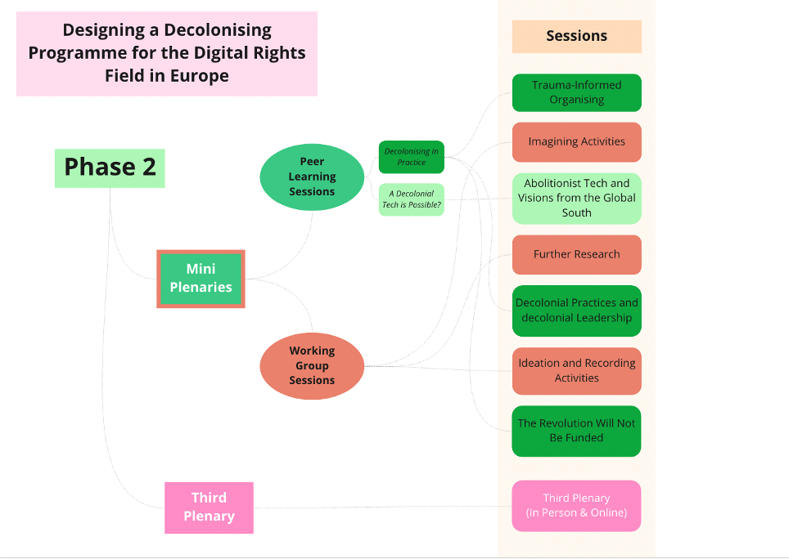
The new formula included a series of online sessions every two weeks, alternating between working group sessions and peer-learning sessions.

During the working group sessions, each working group could decide to have their collaborative time together, without the need to schedule this for themselves. These slots also gave the working groups an opportunity to ask any questions they had or share any feedback regarding the process with the organisers. In addition, the organisers used these spaces to give the working groups more input to help shape the way they worked together and encourage creativity. For instance, one session was focussed on creative writing to imagine alternative futures and included an introduction to afrofuturism.

In our efforts to transform the process into a learning space, we had to tackle some aspects of value and extractivism that are inherent to any work relations within our current system. In the workplace, there is often an expectation to know rather than to learn and to give instead of receiving. The intention is for all of this work to be fairly compensated with a wage. However, this narrative fails to consider the fact that many of us are able to learn in the workplace due to the care work provided by others in our personal and professional lives which in part liberates extra time and mental space. It concerns domestic work, paid or unpaid and emotional support. These dynamics are highly classed, gendered, and racialised and intersect with ableism to impact our economic agency. Therefore, the disability justice movement often invites us to ask whose needs are met, instead of who needs extra care.

The proposed topics were: Trauma-Informed Organising, Anticolonial Tech and Visions from the Global South, Anticolonial Practices and Anticolonial Leadership, and one entitled The Revolution will not be Funded, in reference to the INCITE! Essay.

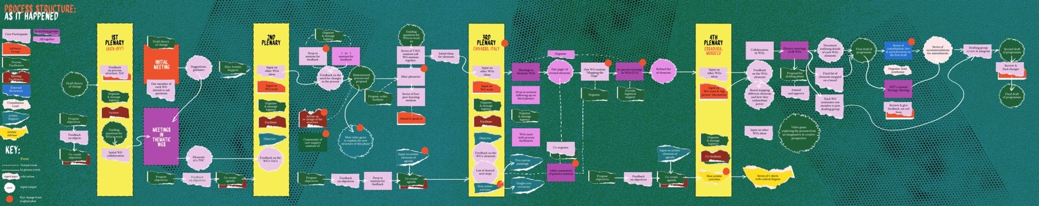
A visualisation of the structure of the process as it happened

⦁ Design Stage 3: Building a community and writing a programme for a new ecosystem (formerly Assembly of the programme)

It became evident following the second plenary, the 1:1 conversations and the drop-in sessions, that in-person connection is necessary to truly enable trust and community-building to allow the work to move forward.

As a result, we held our third plenary together in Chivasso, Italy, where we continued reflecting on activities for the programme. The plenary was the first time many of us met in person and spent a prolonged time together. While organising this plenary, we as a group had to reckon with the fact that, for some, an in-person event also implies having to deal with the harsh visa system, being separated from their role as caregivers, along with the racial, class, gender and disability implications when travelling and crossing borders. The COVID-19 pandemic is not over, and some participants were forced to cancel their attendance due to last minute infections.

At the plenary, we created an open space for participants to bring the topics they wanted to discuss in smaller groups- based on questions and ideas that had arisen in the process thus far. Topics such as decolonising as a process, anticapitalism and technologies, identity politics and collective liberation, reparations and healing, decolonising evaluation frameworks, accountability in an anticolonial organisation, exploring funding dynamics and envisioning alternative models were discussed. The open sessions concluded with an exercise of mapping what decolonising means to us, as a way of bringing together many of the ideas raised in the different discussions.

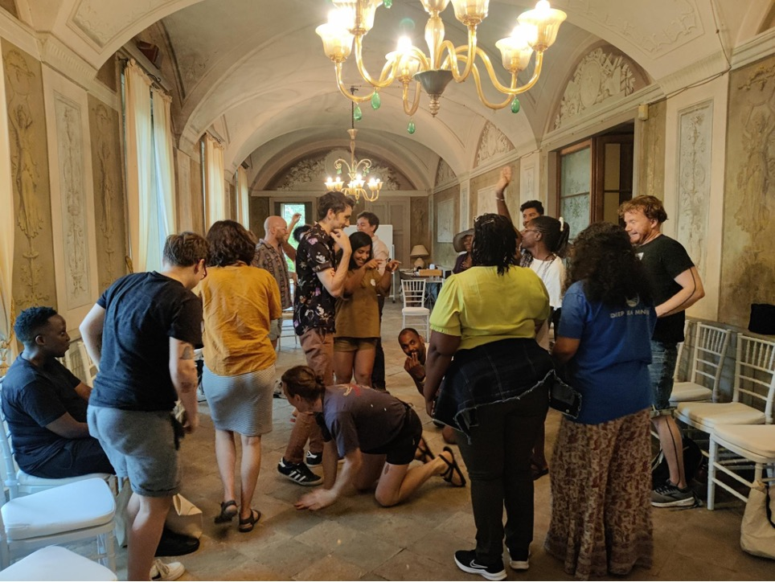

Learning: Organising with joy

Joy and creativity are essential in collective processes that aim to tackle oppression and create liberation. When planning for the plenary in Chivasso, our intention was to create as much space as possible, as we understood that the challenging topics discussed required an environment for exploration. As a result, we made each session optional and avoided going full speed on the first day. We deliberately integrated time for connections and spaces of joy, allowing people to engage and participate in activities together before having to enter what we knew would often be difficult conversations. Inviting artistic practices and fun into planning and as core activities also helped us to ease into our time together. We held a collaborative painting exercise, went swimming, danced, had an open mic session, and even imagined anti-colonial t-shirt slogans. Once again, Ahmed Isam Aldin played an essential role in providing artistic support. One concrete example highlighting the role of artistic support was a ceremony organised during the plenary. During a tour of the host property in the Piemonte region of northern Italy, we discovered that Napoleon had previously been a guest there, and a ginkgo tree had subsequently been planted there in his “honour”. We reflected on what it means to commemorate a figure who held a central role in colonialisation, reinstated slavery in France, pursued violent wars in the West Indies, used torture and massacre and led several colonial enterprises in India and on the African continent. In response, Ahmed decided to organise a collective artistic intervention on the last day to exorcise Napoleon’s spirit. During the ceremony, Ahmed gathered us around the tree.
While some of us chanted, others purified the tree with water, expressing gratitude for bearing the colonial pain. Some threw manufactured objects, read texts and cast liberation spells, or simply chose to remain silent. One of the participants said, “this tree was very far away from many of our ancestors, although it symbolises so much of the violence they had to resist for us to be here, and here we are, facing it, we are getting closer and closer”.

Investing in joy and creativity is not a luxury, it is a necessity to enable transformative thinking, to arrive at a place where imagining a better world feels accessible. In these joyful spaces, we can get rid of the masks we wear to protect ourselves and design the ones we want to play with.

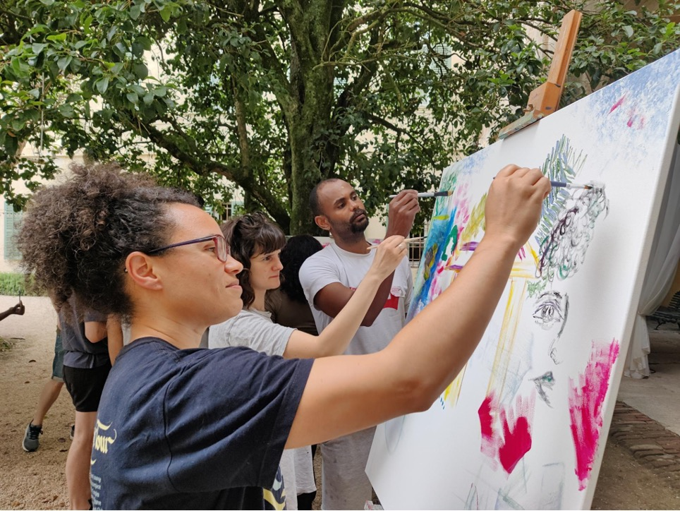

Something that emerged from the closing discussion in the plenary, suggested by one of the participants, was the need to gather input on our draft from people and communities who were not in the room to ensure that no perspectives were missed. We began to search for funding to organise those consultations once a first draft of the programme was ready.

The process took longer than originally planned. As organisers and participants, we learned to be comfortable with this and prioritise reflection, iteration, our respective individual and collective care responsibilities, nourishment and meaningful artistic practice.

Following the third plenary, collaboration in the working groups continued. Thanks to the in-person connection and relationships that many participants had been able to establish, as well as the opportunities for reflection and learning, many more creative and transformative ideas for the programme emerged during this time. Given the significant value that participants expressed for in-person working time, funds were made available for each working group to meet in person between the third and fourth plenaries.

In addition, the decision was taken to also hold the fourth and final plenary in person.

The plenary was a week long, deliberately longer than previous meetings in order to enable participants to come together and connect as a group.

The first two days had open sessions planned for the working groups to use as they saw fit. We also used that time to visit a nearby women’s argan oil cooperative.

Again, time was intentionally carved out for creativity and collective wellbeing. During the previous plenary in Italy, there was a running gag among the participants. Whenever someone said something that sounded particularly iconic, the phrase "that should be put on a t-shirt" would be playfully mentioned. All these sentences and many others transformed into a poem during the open mic on our last night in Chivasso.

We took the invitation literally and in Essaouira, Alice Z. Jones organised a t-shirt-making workshop for the group where we printed these slogans using wax and local dyes.
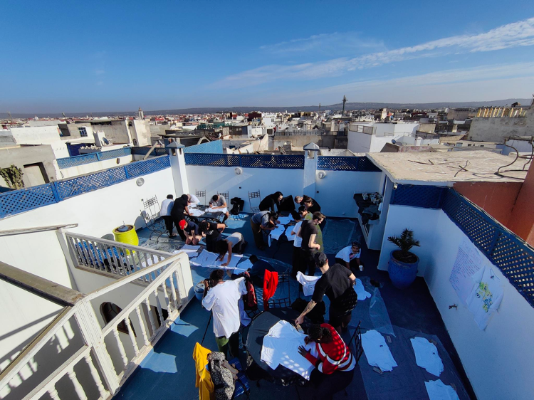

In addition, we held a creative writing session in which we collectively wrote a manifesto for the process that focused on embracing the artistic, political, and spiritual invocative power of manifestos. These were moments of creative joy and mutual discovery that allowed us to hear and see each other under new suns.

As the different sessions unfolded, we witnessed the programme coming into shape before our eyes. The road was full of questions and excitement as we figured out: “How do we ensure the resources really get redistributed?” “How can we mitigate co-optation here?” “How do we recognise and compensate for the work that has already been done?” And most importantly, “How do we not create another mechanism that exhausts or silences radical voices?”. We were at that moment a world within a world, with a particular energy flow that arises when change feels attainable.

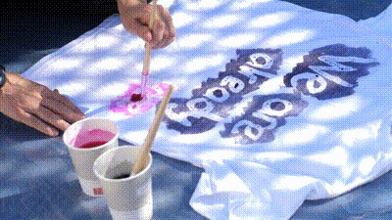

A concrete reminder of our commitment to practise our beliefs came in the aftermath of a harmful incident that occurred during this fourth plenary meeting, held in Essaouira, Morocco. This called for the prioritisation of community care structures to address the harm and begin healing, even if it caused disruption to the process timeline. Therefore, we reshaped our in-person meeting to respond to the immediate needs of the participants and left the final assembly of the programme for a later online meeting. Here again, we took the decision to alter the agenda to allow space for what was happening and deal with it.

The deeper one immerses themselves in an anti-colonial ethos, the more unbearable the violence of our colonial reality becomes. Truly engaging with anti-colonial dreaming means continually confronting the intolerable aspects of the present time and time again. It also makes it very clear how different everything could be. There are more generous and loving worlds to build. This is a result and a necessary step in such work.

It also requires us to create practices to take care of those emerging emotions, the resulting internal and external conflicts they create, and the new dimensions of colonial collective traumas that must be addressed. At that moment, it was important for us to act in alignment with the programme we were building and to practise what we preach, to the best of our abilities. It became impossible to detach our personal identities from our collective actions. As we were calling to centre community-building in all parts of the programme, we ourselves were going through a crucial community-building moment.

Learning: Building around a violent world

An important learning is that due to the visa-apartheid world we live in, it is extremely difficult to organise events in places where there are low to no visa requirements for people from the global south, especially people from the African continent. Considerations about travel regimes also include bearing in mind the screenings to which transgender people are subjected when travelling and the risk of violence they may face in the process.
Another important learning is that when organising gatherings centred on oppression with people that are directly negatively impacted by it and work on it as activists, there is a need for after-care, as well as care during the meeting itself. These times of imagining, dreaming and community are followed by coming back to business as usual and can create a feeling of depletion and disconnect.

After a collaborative effort that involved ideas from the different working groups, review by the participants, and a drafting group among the participants, we arrived at a first draft of the decolonising the digital rights field in Europe programme.

We followed the first draft with a consultation process to make the draft programme publicly available and offered stipends to people with crucial perspectives that we felt had been missing in the process so far. The programme was made available in seven languages, including an audio version, where feedback was gathered in focus groups, one-to-one interviews and through a public survey. The gathered feedback was then shared with the participants in the process as we held a session together to identify ways to fill the gaps and address key needs that arose in the consultation.

2.3 Phase III: Implementing the programme and transitioning to a new organisational structure

Once the decolonising programme is launched, the final phase of our current process will open. In this phase, we seek to ensure the sustainability of the work by preparing the conditions for the activities outlined in the programme to be implemented. This will, in many ways, lay the groundwork for future beginnings and imaginations.

What we envisage for this phase is for a collective that emerges from our process to take up the coordination and ownership of the programme moving forward, decentring dominant actors such as DFF and EDRi, and allowing for the implementation of the activities proposed. This collective called Weaving Liberation will seek to operate in a transformative way, in accordance with the values and learnings taken from the process.

We are currently working on a plan to smoothly transition the coordination and ownership of the process from DFF and EDRi to this collective. Our goal is for this to be done measuredly to ensure the sustainability of the process.

We hope that this new collective and the implementation of the programme will open 2024 with new possibilities for the digital rights field in Europe.

Resources:

- White Supremacy Culture in Organizations, Dismantling Racism Works adapted by The Centre for Community Organizations: https://coco-net.org/wp-content/uploads/2019/11/Coco-WhiteSupCulture-ENG4.pdf

- Strategies for building an organisation with a soul, Hope Chigudu and Rudo Chigudu: http://airforafrica.org/wp-content/uploads/2015/09/Strategies-for-Building-an-Organisation-with-Soul-for-web1.pdf

- Building Accountable Communities Kiyomi Fujikawa, Shannon Perez-Darby, and Mariame Kaba: https://bcrw.barnard.edu/event/building-accountable-communities/

- Can grassroots groups genuinely partner with NGOs? https://thinkingdoingchanging.com/2022/10/12/can-grassroots-groups-genuinely-partner-with-ngos/

- Utopies, AssiégéEs # 4 : https://issuu.com/assiege-e-s/docs/revue_nume_rique_correction_finale_

- Schools of the revolution, The Funambulist # 49: https://thefunambulist.net/magazine/schools-of-the-revolution

- Emergent Strategy, Adrienne Maree Brown, 2017

Anticolonial Practices and Anticolonial Leadership, hosted by Coumba Touré and Anasuya Sengupta, Peer-learning session part of the decolonising process for the digital rights field in Europe, 2022

Focus on shared leadership: how the shared leadership was organised

Laurence Meyer and Sarah Chander

We, Laurence and Sarah, shared the role of co-leads in the design phase of the decolonising process. These responsibilities were taken in our respective roles as Racial and Social Justice Lead at the Digital Freedom Fund (DFF) and Senior Policy Advisory at European Digital Rights (EDRi).

We shared the lead on:

⦁ Strategic planning and decision-making - including shaping the process (including its structure and who was involved), developing proposals for the next set of goals and how they might be attained, analysing issues and finding solutions, and setting the scope and working on the vision, etc.

⦁ Project management - drafting timelines, discussing changes, making sure things stayed on track etc.

⦁ Development of content for the process (drafting of the programme with input of participants and support from consultants etc.) and coordination of the different working groups.

The management of the team as well as the operational management (drafting and editing grant proposals and funding reports, logistical coordination, communications work etc.) were mainly the responsibility of DFF, according to prior agreement between DFF and EDRi. As a result, this part of the work was led by Laurence.

Why shared leadership

The idea of shared leadership deeply questions the idea that ONE person can have final responsibility for project management, ideation, and implementation. And that ONE person, alone, can be equally good at all these aspects of leadership, all the time.

The assumption of singular leadership by definition excludes many people who have responsibilities for caregiving that they cannot or will not outsource to others. These responsibilities include taking care of their children, nephews and nieces, parents, uncles, cousins, and other loved ones. Furthermore, it also fails to accommodate numerous individuals simply due to the amount of stress and pressure it creates. Such circumstances may significantly amplify mental health conditions, particularly when no systems of care are in place. Care responsibilities and mental health conditions are not neutral; they disproportionately affect people facing multiple forms of oppression, such as gender, racial, border, and class injustices. Single leadership models evade collectivity and our need for support and connection in all that we do, in favour of unrealistic goals of individualism.

Here is what we learned from our experience of co-leadership: Shared leadership creates space for dreaming, venting, and daring

A large part of any process that aims to challenge the status quo is imagining. It is crucial to have dreaming companions that do not impose limitations of false realism, but give the imagining more layers, depth, and dimensions. These companions should take you seriously in your musings and aspirations, and try to understand them. To have individuals who invite you into their dreaming, where they share the fragments of worlds they sketch when they think of liberation and collective joy is a powerful infrastructure of care.

We often shared references of TV shows, books, music, and films, sometimes even sending each other quotes that we liked. This impacted the way we approached our work as it created a space of joy that we were eager to return to and sustain. We had fun, and we still are having fun, and in doing so, we encourage radicalism and bravery in each other.

We also learned of the necessity of holding each other accountable. Not to any efficiency standard of productivity, but to recognise the value we bring to our work in ways that are often undervalued in broader society. As two women of colour, it was crucial for us to have someone who could fully understand the situation. We needed a person to confide in while navigating the discriminatory, sexist, and racist realities, as well as the overwhelming challenges that come with the burden of responsibility and decision-making. It was important to have someone who shared a similar stake in the responsibility and an aligned vision of the process who could also comprehend the contradictions and dissonances that those things brought to light.

We had many discussions that began with expressing frustration, anger, or sadness, sometimes unrelated to the process at hand. These conversations prompted solutions to explore in the short term, while also leading us to imagine viable options to prevent similar situations from occurring. Some discussions ended with jokes about what angered us, while others brought a sense of relief and understanding. This emotional labour has been crucial in sustaining us.

Not being alone in leading this process also allowed us to be more daring because there was someone who was ready to share the risk and to talk it through had the same level of responsibility – and who was neither your line manager nor someone you manage. In many instances, we chose to radically change the planned agenda to respond to the current situation. For example, when a conflict arose that changed the design of the process or when responding to a racist event by prioritising addressing it rather than following the planned agenda. Shared leadership created the space to be flexible and resist our internal urges to conform to an external agenda that did not serve the goals of the process. It also allowed us to test and fail with the assurance that we had each other. In many ways, this has also enabled our growth, or at least shed light on how we have grown in ways we might not have noticed if we were working alone.

Shared leadership in this process was fundamentally a space for mutual care and support. We developed ways to offer support to one another while also integrating how we organise the process. This departed from norms and priorities that do not serve us, our bodies, or the community we created. Shared leadership for us is a care partnership, where the many responsibilities implicitly expected of us (and that we expect from ourselves) as Black and brown women could be shared but also transformed. Care was transformed from an ‘extra’ or a ‘burden’ into a definitive organising principle, transformed into opportunities to realign our work around what really matters and brings joy.

Some resources:

- Achieving Transformative Feminist Leadership, A Toolkit for Organisations and Movements, SRILATHA BATLIWALA MICHEL FRIEDMAN for CREA: https://creaworld.org/wp-content/resources/toolkits-and-manuals/Feminist-Leadership-Toolkit.pdf
- AWID's Co-Executive Director Model, Hakima Abbas, Cindy Clark, 2019 https://www.youtube.com/watch?v=3qrqAKNTGpI
- Learning from Co-leadership, Engine Room, 2023: https://www.theengineroom.org/learning-from-co-leadership/
- Unlearning Leadership, Healing Justice London, 2022 https://healingjusticeldn.org/resources/unlearning-leadership-pt1/

Focus on whiteness: What does it mean to grapple with whiteness in a decolonising process?

Written by Joel Hide and Claire Fernandez, with contributions from Azar Causevic and Asli Telli, reviewed by Mauricio Lazala

How whiteness showed up

Of the thirty core participants in the design phase, around half identify as white. However, it is crucial to note that whiteness is relational and has different definitions and meanings across different regional and cultural contexts. As a result, some participants felt white in some settings and racialised in others. Reflecting on the process, it is clear that we, as white-identifying members of the group, did not arrive at the process with an anchored practice of recognising, discussing, and proposing measures to tackle white supremacy culture. This often led to standing still and looking to racialised participants for guidance and a lack of proactiveness.

For the first half of the process, whiteness was not addressed by the white members of the group publicly, nor were there open conversations about how it emerged in the process. We did not have a structure in place to prevent potential burdens on other group members and hold ourselves accountable when it did.

As a result, many of the necessary tasks and care work within the groups were shouldered by women of colour, Black women and queer people of colour. This occurred during a process that required considerable time and emotional investment from the participants, some of whom were juggling their day jobs and other responsibilities alongside their involvement in the work.

What worked well

Following a conversation about healing at the third plenary, instigated by Jennifer Kamau, we created a white community of practice. The initial plan was for white members of the process to trace their own history and relationship to colonialism, while reflecting on the forms of repair that could be put in place.
This was proposed as a necessary step for building relationships of trust within the group.
Having a white-only group created a space for discussions about whiteness to occur in a way that was not burdensome for the BPOC members of the group. Though the group only met three times, it was a relief to have a space where we, as white people, could begin to move past feelings of white guilt and take responsibility for our own family histories. In addition, some working groups also built in time to collectively reflect on the various positionalities and relational privileges held by the members of the group.

This white community of practice increased knowledge, consciousness, and capacity among the white members of the group to act collectively. A clear example occurred during the final plenary in Essaouira. The morning following a racist incident that had greatly impacted the group, we split into two groups under the direction of the process leadership. BPOC members created a space, with Jennifer facilitating the process and healing from the event. Meanwhile, white-identifying members formed a group to discuss and propose a list of actions to take in response to the incident, which were then proposed to the wider group for discussion. In the end, these included a direct action at the site of the incident undertaken by white-identifying members of the group, several follow-up actions online, and the establishment of a wellness fund for BPOC participants to use after the event.

The pattern of white affinity groups taking on the labour of coming up with a range of proposals to tackle racism, while proposing these options to BPOC for feedback was crucial. This approach meant that white people assumed some responsibility for the labour of generating ideas and implementing them, while allowing BPOC members to maintain control over what actions were ultimately taken.

Within this vein, a specific session on how to tackle resistance to the decolonising process within the digital rights field was held at the final plenary in Essaouira. This was a space for white-identifying participants to do the work of identifying how white supremacy may strive to persist, as well as what strategies we could identify to ensure the success of the programme.

What we learned

There is a need to do more work in addressing and building the readiness of white people to tackle white supremacy culture, while engaging as comrades in the struggle with BPOC. This preparation would ideally take place before we begin to participate in multi-racial decolonising processes. A helpful tool is “the ladder” (see diagram in Tema Okun’s article below), which highlights the various stages that white-identifying people need to navigate to effectively engage in anti-racist struggles. It recognises that they may find themselves on several rungs at once or alternate between rungs, sometimes regressing when confronted with challenges.

In line with this, it is essential the white community of practice is established from the beginning of the process. This practice will work to support white-identifying members of the group moving up the ladder and create the conditions for a “community of love and resistance”. During the decolonising process, there were moments when we were able to achieve this state, such as in response to the racist incident in Essaouira, but not consistently. Moreover, a stated goal at the outset of the white community of practice was to share concrete outputs from the group on how its members planned actions related to repair and healing, based on acknowledging their own family and personal histories of whiteness. However, this was not achieved due to the group establishing too late in the process to do the foundational work on whiteness that was crucial for making progress towards concrete actions.

In addition, it could prove beneficial for any white community of practice to draft an emergency plan of action for responding to racist incidents. This plan could include an outline of potential scenarios of how white members of the group can act to limit the harm caused by racism, ultimately enabling a space for healing.

Some resources:

⦁ Podcast “Race Traitor”, by Phoebe Unter: https://www.theheartradio.org/race-traitor-1
⦁ Survey for White Artists by Latham Zearfoss & Ruby T: https://monday-journal.com/survey-for-white-artists/
⦁ Roots Deeper than Whiteness, by David Dean: https://whiteawake.org/2018/10/27/roots-deeper-than-whiteness/
⦁ “From White Racist to White Anti-Racist”, by Tema Okun (includes ladder diagram) https://www.fammed.wisc.edu/files/webfm-uploads/documents/diversity/LifeLongJourney.pdf
⦁ White Supremacy Culture, a website created by Tema Okun: https://www.whitesupremacyculture.info/
⦁ “10 ways white supremacy wounds white people: A tale of mutuality”, by Greg Elliott: https://afsc.org/news/10-ways-white-supremacy-wounds-white-people-tale-mutuality
⦁ “White Anti-Racism Affinity Groups: I Used to Be a Skeptic, But Now I’m an Evangelist”, Justin Cohen http://www.justinccohen.com/blog/2016/10/28/white-affinity-groups
⦁ “Race Based Affinity Groups”, by Taryn Strauss, Rev. Elizabeth Nguyen, and Jennica Davis-Hockett: https://www.uua.org/sites/live-new.uua.org/files/race_based_affinity_groups.pdf

Looking back together: collective reflection on the process

Compiled and drafted by Abby Oulton, Esra Tat
Reviewed by Laurence Meyer, Ioana Barbulescu, Sarah Chander and Joel Hide.

This section outlines reflections from participants of the process – what they thought worked well, what could be improved, and any tensions they were left with.
This feedback was gathered by Abigail Oulton and Esra Tat and was collected through video calls, text messages, and an online survey. The following core participants, advisory group members, and process facilitators provided their inputs: Asli Telli, Nadia Benaissa, Claire Fernandez, Raegan MacDonald, Luca Stevenson, Cianán Russell, Ali Khan, Asja Lazarević, Esra Özkan, Alyna Smith, and Salmana Ahmed

When asked what they appreciated most, respondents highlighted the following facets of the process. They found delight in the fact that the process intentionally made room for dreaming and generating ideas. They also appreciated the facilitators for their care, responsiveness, and commitment to align practice with liberatory values. They enjoyed the collaborative nature of the process, which was designed around small group work. They expressed a sense of clarity regarding the roles of different actors in the process. They appreciated the collective’s flexibility and generally found being part of such an endeavour inspiring.
Participants expressed their gratitude for the existence of the process and their appreciation for being involved. Even while recalling frustrating moments or future uncertainty, the participants expressed curiosity, gratitude, and hope that their efforts will seed real change. As co-creators of the process and participants, they sincerely cared about others having a chance to learn from it.

I feel like decentring the power of oppressive institutions and reallocating resources will be a tough task. In many instances, we are still at the stage of acknowledgement with healing and reparations being phases that are yet to come. Creating a new ecosystem is a brave target...I remain hopeful and always thankful for all the selfless great work.
Claire Fernandez

Asked about the challenging aspects, respondents considered how the process may have been otherwise, if not for its origins in the COVID-19 pandemic precluding the possibility of gathering in person. Participants who became overwhelmed with the demands of online work, balancing care responsibilities, and domestic labour found it challenging to sustain their engagement. The resulting fragmentation became evident in some groups through imbalances of power and capacity, particularly when some individuals participated as volunteers receiving an honorarium, while others were there as part of their paying jobs.

Main themes
Some aspects reappeared in the feedback of some of the participants and therefore emerged as the central themes. These were:
⦁ Relationship building and centring shared values
⦁ The structure and flexibility of the process
⦁ The need to centre marginalised groups
⦁ The importance of care
⦁ The need for ongoing learning and unlearning
⦁ The need to acknowledge power dynamics
⦁ Artistic practice, visioning, dreaming, and pleasure as a central method

Relationship-building and centring shared values
Participants expressed their appreciation for the value placed on relationship-building. One example of this was the use of smaller working groups, where closer bonds could be formed alongside those within the wider group.

As with any process, some are naturally more self-assured and outspoken than others. This dynamic can potentially be reinforced when people do not know each other. [It] was really important that smaller groups, particularly the working groups, be the main mode of operation. This approach served to equalise the dynamic and promote a fluid dialogue of connection, while building through shared understanding.
Alyna Smith

In-person time was also crucial for this process, especially during the final two plenary meetings held in Italy and Morocco. Unfortunately, the first two plenary meetings were not held in person due to the pandemic. In addition to the plenary meetings, some participants were also able to gather in person within their working groups for a meeting, where they enjoyed the experience of finally connecting and co-working as a smaller team. The flip side of this was that many participants struggled with the online aspects of cooperation.

I enjoyed the plenaries in Italy and Morocco (really caring, joyful events) where we were able to build relationships. It’s great to know that these relationships are thriving in many different avenues.
Esra Özkan

The online dimension of the work was really, really challenging.
Alyna Smith

Many suggestions for improving the process involved even more centring of relationship building, particularly in the first half of the process which was held online.

I would spend more time helping people get to know each other. One issue we later realised was the lack of a values check-in. It may have happened during phase 1, but since a lot of new people joined, I’m not too sure. Spending more time getting to know each other and creating a safe space would have been beneficial, especially when a process is online.
Myriam Douo

The flexibility of the process

Another key theme was the participants’ appreciation for the flexibility and responsiveness of the process facilitators. This allowed the process to be adapted and revised in response to feedback and needs that emerged over time.

This was a great learning process for me. I really liked the way the facilitators were flexible and listening to the participants and adapted the process to what the participants wished.
Myriam Douo

Participants were grateful for the flexibility of the process and for their willingness to slow down, listen, and take care of each other. The process attempted to centre relationship building; both in principle and in acknowledging the reality that holistic work requires collective effort to create a space where all participants can exist as their whole selves.
They appreciated that the informal and personal aspects of their engagement were valued, and they were grateful for the diverse experiences and backgrounds of their fellow participants.

I appreciated being involved in quite intellectual reflection about very complex issues and experiencing the spirit of 'collective thinking' throughout the process.
Luca Stevenson

One participant wondered if the process would have worked better if held as a long, single, in-person meeting. This final reflection highlighted the tension between the need for a longer process to enable participants the time to reflect, ideas to mature fully, and relationships to bloom. They suggested the potential advantages of a period of focused work together with fewer external distractions.

I really appreciated that the process gave space and time for this work… At the same time, ... it does seem like a lot of the most meaningful work was achieved (including the connections, relationship-building, deep reflection) at the in-person plenaries. I wonder if the whole exercise (or the bulk of it) might not have been achieved with one (or maybe 2) intense week(s) together? A challenge with the lengthy process was keeping the thread, with long gaps between sessions and contact with work group partners. A lot of time was spent catching up and recapping each time. As a result, it was difficult to have everyone together at any given moment, which meant more interruptions and delays.
Alyna Smith

The need to centre marginalised groups

Some participants requested more representation and leadership from members of communities most impacted by systemic oppression. They appreciated the feminist, queer, and anti-racist aspects of their organising, while simultaneously highlighting that the process could have included more people directly impacted by technological harms, including more of a focus on disability justice.
At the same time, participants were aware of the tension between wanting more leadership to come from the most marginalised communities, the fact that members of those communities already disproportionately bear the burdens, and the risks associated with inciting social change. While recognising that these tensions are not resolvable without large-scale systemic change, they wondered how best to care for each other and move towards their goals in the meantime.

There was still a large proportion of white members in the process, which might be reflected in some results (or maybe it's my perception because my group was mainly made up of white members). Making sure [working] groups had a balanced representation would have been good, I think.
I think one thing that could have helped is to ensure that there was more representation from communities that do not have basic internet access, and as a consequence do not have a seat at the table when discussing digital rights.
This could have been done via local, in person, community meetings (but again I recognise that Covid did not make this possible, to no fault of the organisers).
Myriam Douo

Participants wondered how to prevent burnout and how to offer better care to their collaborators who suffer most intensely from the impacts of the oppressive infrastructures they are working to dismantle. Specific comments referenced the fact that, given the racist events that members of the group were subjected to during the final plenary, in hindsight it would have been helpful to have a concrete action plan and security protocols in place to protect members of the process in such a scenario.

A key learning is that we cannot isolate ourselves from colonialism, racism, or other forms of oppression and discrimination. It surrounds us, and we encountered it head on in Morocco at Le Love Caravan Cafe. Having more mechanisms in place to anticipate such risks and to act more swiftly and decisively when it happens would definitely be something to consider in the future.
Raegan MacDonald

[In future we should] anticipate that this [racist incidents affecting the group] would be the case wherever we go and create security protocols, leaving more time for unforeseen developments.
Claire Fernandez

Visa issues/borders: These barriers made it difficult for some core participants to get to places and, in some cases, prevented them from participating at all. It remains a challenge for this type of work as we think of how to navigate increasingly hostile and violent border policies, vis a vis a commitment, to bring people from many different backgrounds together when we operationalise this programme.
Salmana Ahmed

When discussing potential improvements, participants mentioned the importance of more explicit opportunities for learning and collaborating with organisers from the communities most impacted by changes in the digital rights landscape. Based on the anti-colonial understanding that knowledge is held collectively, participants stated that they would like to see skill-sharing, community-based learning, and other opportunities to learn together play a larger role in future processes.

Thinking within the limitations of existing funded NGO structures has limited our analysis and inspiration. Many discussions hit roadblocks as people were trying to check whether this or that proposal could be implemented by their organisations right away.
There were some spaces dedicated to political education, but this was mainly via online sessions where people did not join or engage deeply. My suggestion would be to seek some level of political alignment within the group to make it easier to go deeper.
Esra Özkan

The importance of care

Several participants emphasised the centrality of care to the process as a crucial aspect. This is closely linked to the flexibility of the process, as both the facilitators and the group as a collective were prepared to change plans entirely to prioritise the wellbeing of the group and create space for healing.

Emphasis on care as a basis for working together… commitment to providing whatever support is needed, being as responsive as possible to needs and being flexible enough to shift gears if called for.
Alyna Smith

The work or desire to be productive never felt more important than the people showing up in the room and their individual experiences and/or needs. People came first.
Salmana Ahmed

I think many support systems were put in place to ensure that the impact of structural oppressions could be mitigated. I think there could have been a stronger emphasis on the support systems and perhaps more reminders that they were there both online and offline.
Ali Khan

This care was particularly crucial for members of the group who exist at the intersections of racial and gendered oppression. Feedback from women of colour in the group revealed that a particularly high emotional and workload burden tended to fall on them, leaving some of them feeling depleted following the process. Decolonising work enhances racial trauma, and although some measures were put in place to address this, there was a need for further support and aftercare frameworks.

The need for ongoing learning and unlearning

The need for ongoing unlearning occurred during the design of the process. This was addressed by holding dedicated sessions to build a process that actively challenged hegemonic ways of doing things, and where the process facilitators as well as participants worked to put anti-colonial values into practice.
The participants appreciated that regular sessions for reflection, feedback, and adjustment were built into the schedule. Members of the advisory committee ended up contributing differently than originally imagined, shifting in response to the group’s needs from hosting work-focused check-ins to presenting and participating in peer-learning sessions that prioritised knowledge exchange. Those involved in the peer-learning sessions found them thought-provoking and gratifying. In addition, participants enjoyed and expressed a desire for more support in learning transferable frameworks. These frameworks, such as the theory of change framework and ways of working collaboratively, and the explanation of team rhythms received at the beginning of the process, would bring these lessons into their other projects and communities.

I learned about various forms of group facilitation and process design.
Luca Stevenson

I learned how to let go of focusing solely on outcomes and how to embrace the process. This was certainly not easy, as we live in a world where outcomes are always the main goal.
By embracing the process and doing things step by step, it became clear towards the end how meaningful our journey was. It took me a while to actually see that, though I think I really understood it when I saw the visual representations of the process and the work of the different working groups. It was a big ‘aha moment’.
Ali Khan

By acknowledging that decentralised and emergent collaborations are unfamiliar experiences for many, some participants advised that adding dedicated time early in the process for learning and unlearning would help those gathering find their places in such a process. Time to learn together about each other’s contexts and agreeing on shared definitions of the concepts they intended to work with was also suggested.

The need to acknowledge power dynamics

Regardless of how they came to be involved in the process, many participants shared that they sometimes struggled to understand how to engage, what was expected of them, and where power lay in the process. The relative novelty of such an open, decentralised process caused some of this uncertainty. Much of it was also tied to the tensions that arose when working to centre relationships, building and rejecting urgency while nevertheless being bound to deliver clear outputs to funders on an externally determined timeline. While advisors and consultants were involved in shaping the process from the ideation phase onward, their contributions were not always explained to other participants as the results of consultation processes early on.
In addition, each participant had a different amount of time and capacity to contribute. This was shaped by whether they participated in the process within the context of a paid job or as a volunteer receiving an honorarium. In addition, other factors such as care responsibilities and the distribution of these burdens were influenced by race, class, and gender.

Structural oppressions have surely impacted the process in various ways by limiting the participation of certain communities or perpetuating power imbalances within the group. Having a process started by two big digital rights organisations who then, in a certain manner, picked and chose individuals to participate in it, necessarily will reflect power imbalances. However, I think organisers did their best to mitigate these impacts and centre marginalised voices, along with recognising and acknowledging that even this process or any process is immune to structural oppressions.
Asja Lazarević

Linked to [sharing what decolonising means to us], might have also been helpful to have spaces for reflecting on our capacity to participate in the process as well as what lived experiences, perspectives, 'baggage', and doubts we may have.
Alyna Smith

For me [structural oppressions] manifested in people being able to participate in this process and 'take their time'. I saw frustration from people who felt the urgency was not considered in the process or had daily struggles that felt more urgent than this. As usual, people with more privilege had less of those considerations and were able to participate in the process with a clear headspace.
Myriam Douo

Artistic practice, visioning, dreaming, and pleasure as central methods

One of the methods used for unlearning dominance was the use of artistic and other creative practices as a central way of working together. This challenged the dominant forms of collaboration that emphasised the written word above all else and diminished visual forms of knowledge production. Participants appreciated that these activities were central to the process, rather than a side activity, and that there was space for spontaneous creative expression, whether in the form of painting, creative writing, ceremonies, or t-shirt making. These practices also created space for joy and pleasure as a core part of the process.

The audio-visual content, both as an input and outcome of various activities, including the process itself, invites contributions with an anti-colonial mindset. The visit to the sacred tree in Italy, along with the creative/ad-hoc ceremony that accompanied it, as well as the first mapping exercise for which we imagined a decolonised digital rights scene in the near future, are all intra-cultural anti-colonial experiments with an artistic touch.
Asli Telli

The online plenary at the beginning of the process was a highlight and stood out from the other online meetings during Covid. I deeply appreciate the positive visioning we did at the outset. These visions still stick with me.
Raegan MacDonald

[This experience taught me the] importance of being intentional about building in lots of moments of care, joy, expression, and creativity (not just flip charts and talkshops).
Alyna Smith

Numerous participants expressed gratitude for the possibility to collaborate on such a visionary and hopeful project that was not overly restricted or focused on limits. These reflections were frequently offered when respondents were reflecting on a struggle and sought to anchor back into the question of why persisting through disappointments and frustrations as a group felt worthwhile. The design process itself, and the way it enabled different actors to come together as a pluralistic group of collaborators, visioning boldly and creating together, offered a taste of what is possible while guiding their attention from what feels hopeless to a tangible vision of what the future could become.
The process encouraged this orientation through its use of trust in working groups, its emphasis on collaboration and iterative change, and through dedicated time for envisioning the kinds of futures participants would feel happier and safer living in.

[I enjoyed] the opportunity to engage with others who do not question the need for decolonising digital rights, the opportunity to learn from them, and to contribute to a collective effort to imagine something that can bring about change.
Asja Lazarević

Conclusion: looking forward to what comes next

At the end of the process, some participants expressed uncertainty regarding what was sustainable and realistically possible. Having been brought together by DFF and EDRi, two established digital rights NGOs, they wondered about the future of the work they had started together. Who, if anyone, owns the digital rights field decolonising process? Should the process be continued by organisations with closer connections to grassroots efforts by and for the most marginalised groups? Can a process be both open for collective co-creation and accountable to external funders for set outputs? Is there a way to have such processes led by those most impacted without replicating the colonial pattern of exploitation of the most marginalised?

The big question for me regards how to empower those involved to take this work forward, where they are - depending on (but also regardless of) their institutional affiliations. How much of this depends on individuals and how much on institutions/organisations, especially in terms of any leadership role(s)?
Alyna Smith

The (draft outline) programme is rich and presents challenges in clearly mapping how shifting power would actually manifest and be measured. Yet I believe the process has already led to some impacts (yes, I said the I word).
Claire Fernandez

I believe decentring the power of oppressive institutions and reallocating resources will be a tough task. In many instances, we are still at the stage of acknowledgement; thus, healing and reparations are phases yet to come. Creating a new ecosystem is a brave target...I remain hopeful and always thankful for the selfless great work.
Asli Telli

In response to these reflections, the organisers endeavoured to develop a transition plan that outlined how this work can be held in a different structure and form in the future, one that better reflects anti-colonial values and movements. One consideration, however, is how it will be implemented sustainably, easing into its newer mode with necessary support from the previous organisers.
Having been encouraged in the process to embrace a relationship with uncertainty that allows for meeting the emergent and unknown with curiosity and hope, participants developed the capacity to carry these and other questions without urgently needing answers. Coming from places where colonialism’s impact looks in part like alienation from each other, the experience of learning from anti-colonial models and practising co-creation from decolonial principles made sure they were reminded of the primacy of relationship and of their influence as forces in a larger ecosystem. Surrounded by fatalistic narratives and despair-inducing news about developments in the digital rights field, the invitation to immerse themselves in meaningful and impactful collective work continuously offered them a way to refresh their connections to grassroots power and hope.

[I appreciated] the imagination, vision, knowledge, and strength demonstrated by leaders and participants in the process to truly shift power. That was incredibly inspiring.
Raegan MacDonald

I mostly enjoyed witnessing the group’s love and solidarity developing as the process advanced along with witnessing Sarah's and Laurence’s exceptional leadership.
Claire Fernandez

I really appreciated being part of such an incredibly diverse and amazing group of people. I went into the process without any expectations and perhaps even assumed it would be similar to other projects I’ve been involved in – mostly white, cis, and heteronormative. To my surprise, the group was not at all like that, and that is probably the biggest factor in the process that led to things being done differently.
Ali Khan

I think the most important thing I learned was knowing that we are not alone in this. There are many beautiful people, each with different backgrounds, experiences, perspectives, and interests, all working towards the same goal.
Nadia Benaissa

Afterword
Claire Fernandez, Director of EDRI

We sincerely hope this blueprint can provide a useful guide and inspiration for future processes and communities working on justice and shifting power, whether in a similar civil society context, or philanthropic, academic, company or social movement contexts.

This blueprint also documents steps, iteration, questions and learnings. It could be what stays when we look back and try to remember this chaotic and beautiful design phase.

The legacy of the decolonising the digital rights field process is much bigger though: it has forever changed the way the field looks at itself, the way funders are approaching it, the way other fields connect to ‘digital’. This process has disrupted the long and unchallenged power that digital rights activists had enjoyed for 20+ years, building on much longer historical dominance.

In a digital society, this power and resource shift is indispensable: to succeed in our original mission of reclaiming power over state and private actors, we need to address all manifestations of surveillance and control, with a justice lens. Our ability to implement the vision of the decolonising programme will be key in the years to come.

I am grateful for Nani Jansen Reventlow’s vision that put us in motion. I am grateful for Laurence and Sarah’s leadership and force that has transformed us.

Thank you to the decolonising process participants for the love and joy, resilience and creativity. Thank you for the support and trust of many more colleagues, supporters, organisations and funders around the process.

I am also grateful for the pain, the discomfort, and even the resistance we faced along the way. For that we have learned that we were doing something meaningful.

Credits

The participants in the Decolonising Digital Rights Field process were:

Alejandro Moledo (European Disability Forum)
Alexandra (Digital Defenders Partnership)
Ali Khan (Open Society Foundations)
Alyna C. Smith (Platform for International Cooperation on Undocumented Migrants)
Arthur Steiner
Asja Lazarević
Anasuya Sengupta (Whose Knowledge?)
Anna-Dorothea Grass (Bosch Stiftung)
Asli Telli (Alternatif Bilisim)
Azar (Kvir arhiv)
Carine Marzin (European Disability Forum)
Chenai Chair
Chris Jones (Statewatch)
Cianán Russell
Danilo Krivokapić (Share Foundation)
Eleftherios Chelioudakis (Homo Digitalis)
Esra Özkan (Justice, Equity and Technology Table)
Gabriela de Oliveira (Glitch)
Inés Binder (Digital Defenders Partnerships)
Jennifer Kamau (International Women* Space)
Juliana Wahlgren (European Anti-Poverty Network)
Karisia Gichuke (Open Society Foundations)
Luca Stevenson (European Sex Workers Alliance)
Mukasa (International Trans Fund)
Myriam Douo
Nadia Benaissa (Bits of Freedom)
Nakeema Stefflbauer (Frauenloop)
Raegan MacDonald
Roxanna-Lorraine Witt (save space e.V.)
Salmana Ahmed
Seyi Akiwowo (Glitch)
Temi Lasade Anderson
Vidushi Marda
Willem Lenders

Artistic team:

Illustration by Kruthika N.S.
Diagrams by Tessa Curran
Graphic Design by Claire Zaniolo
Visual Identity by Alice Z. Jones

This narrative document was reviewed by Ioana Barbulescu, Sarah Chander, Claire Fernandez, Adélaïde Hirwe, Joel Hide, and Laurence Meyer.

The blueprint project was coordinated by Laurence Meyer.

“The past cannot be forgotten, but we can redistribute the burden of carrying it. Reconciliation of the main actors in the digital rights field and the main targets of societal discrimination is imperative. That means admitting the wrongdoings, being honest with each other, and seeing if it is at all possible. Sometimes it is not. Capital is what's yours, not hers. Majuscule. Start of a sentence, the first word. But not the last. We know the empire of white supremacy is the biggest thing to tackle. We know borders will always separate, the question is: who is going to be trapped. What madness to think we can stop people from climbing over walls with barbed wire when the violence we caused is the reason they attempt to climb on them. Am I stuck in this system? Never! Like my ancestors and your ancestors before you, I shall fight! It will take a lot to make the sun rise, to be comforted with the embrace of warmth on your skin, like a grandmother comforts her grandchild who knows what it is to fight, to resist, to be in pain, to recover, to return in a stranger form, transforming into a rooted tree. Roots and family trees are the roots of a tree, and how deep down and old they are is also how long our generations have lived on earth. Find the roots of your fears and search within you and your past. Let´s remove all the sharp edges between us. Maybe they would give us pleasure, solace, take my mother to the forest, destroy capitalism, calculate freedom, feed our children honey when they get sick. Our smile like barbed-wire, shiny and dangerous. They stood in the hallway with cut lips and bruises, staring at each other. They couldn’t remember who raised their fists first.”

Decolonising Digital Rights Field in Europe - collective writing manifesto, Essaouira December 2022

Annexes

Graphic Recordings
Second Plenary

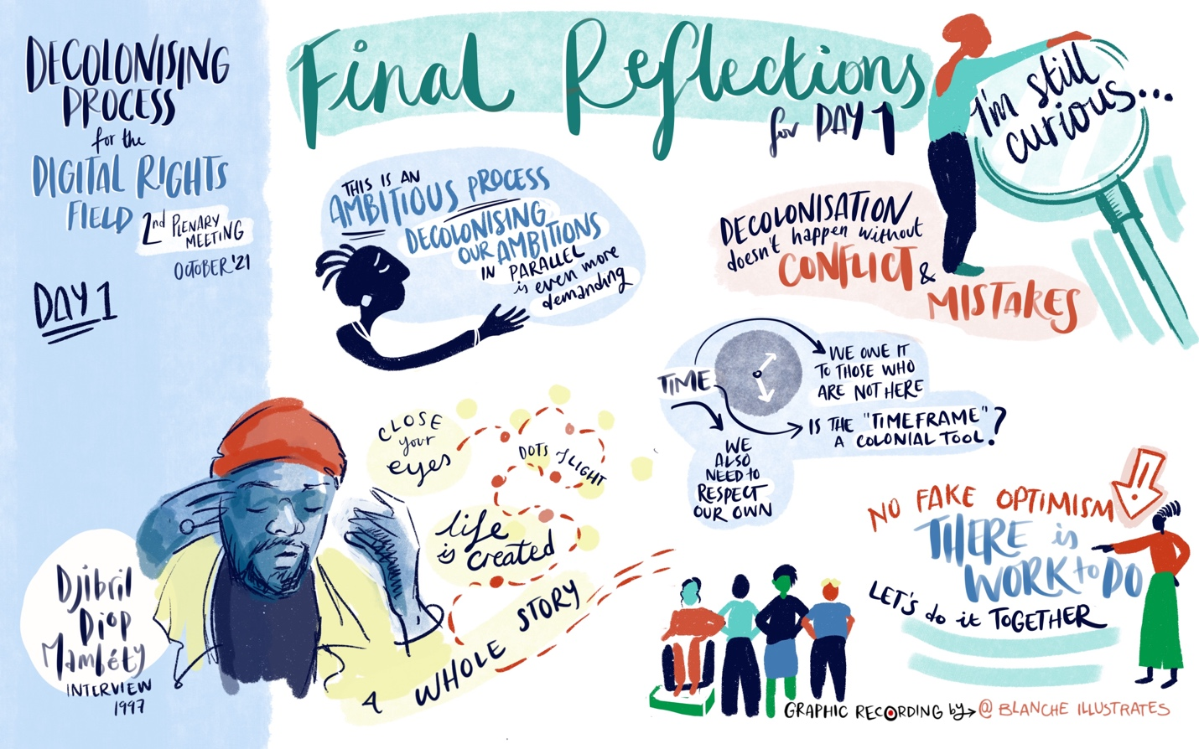
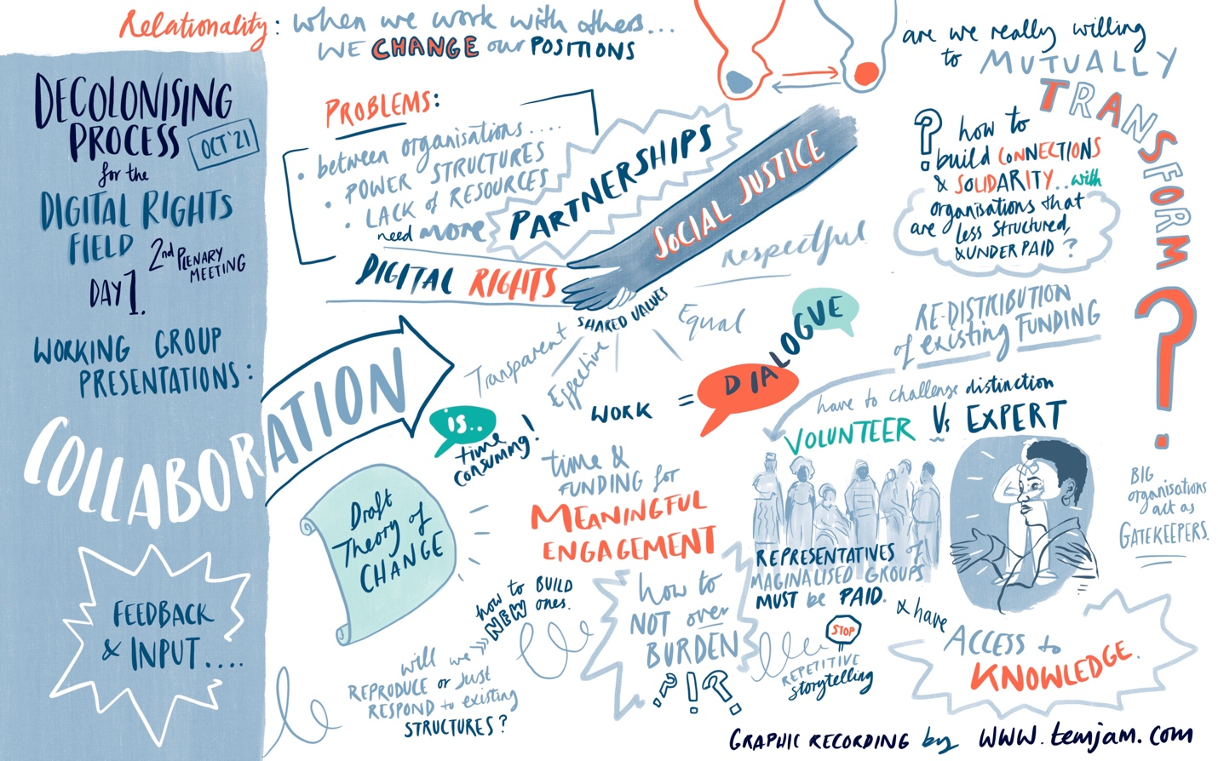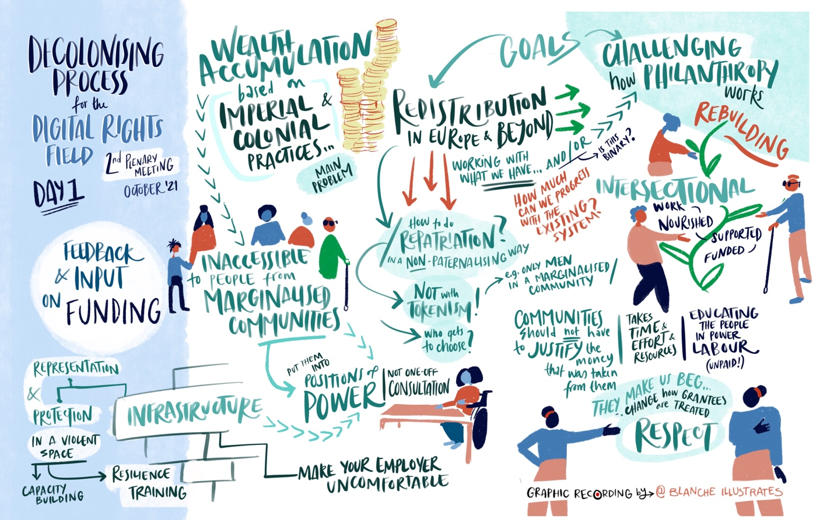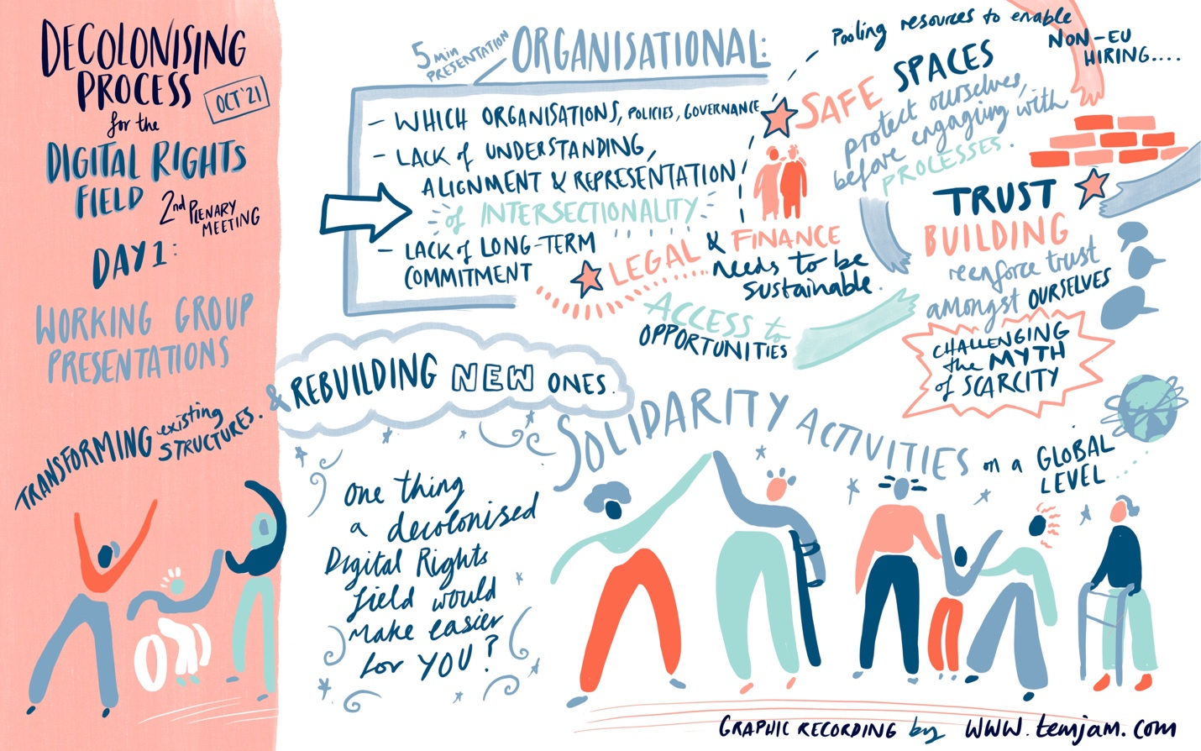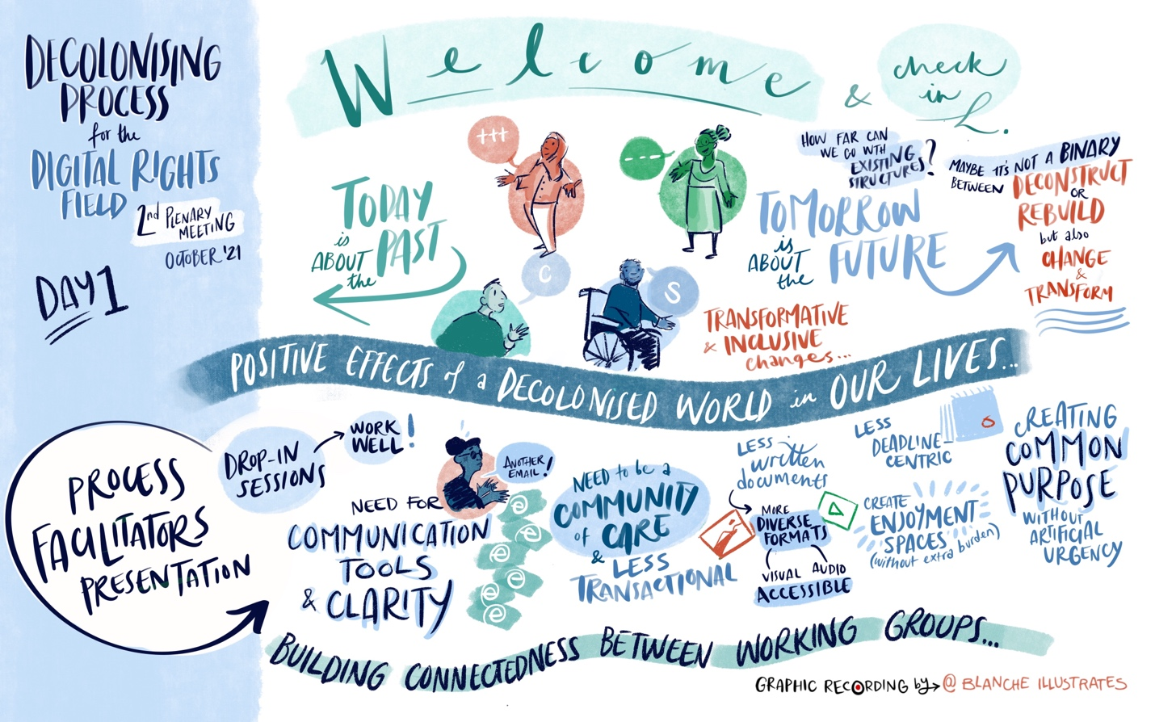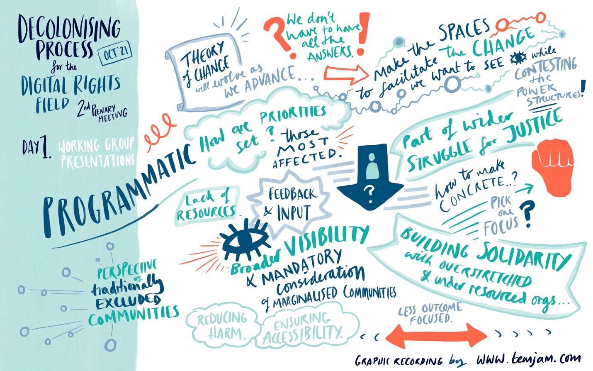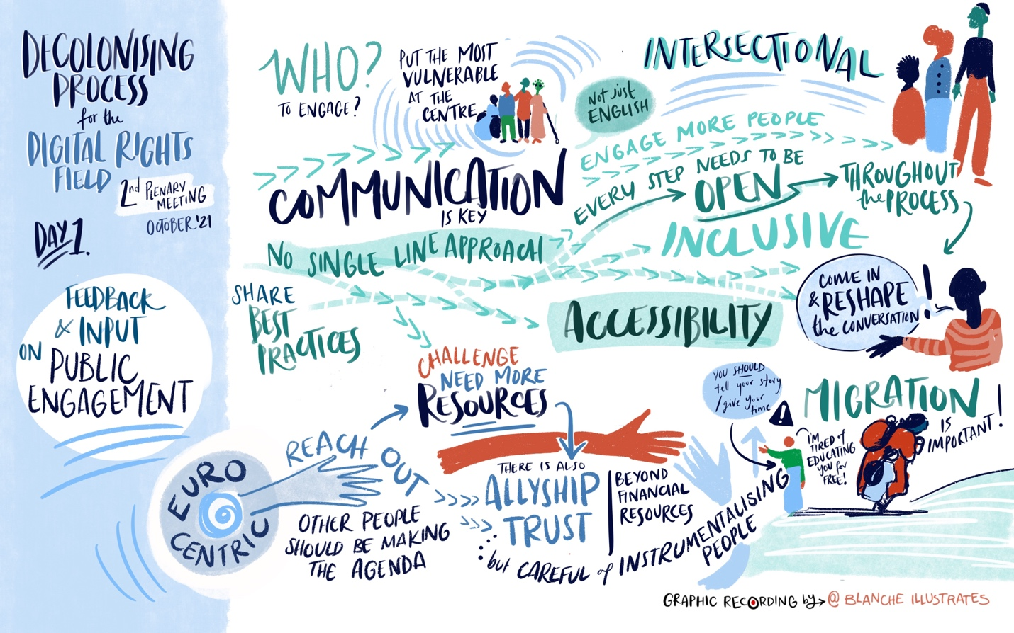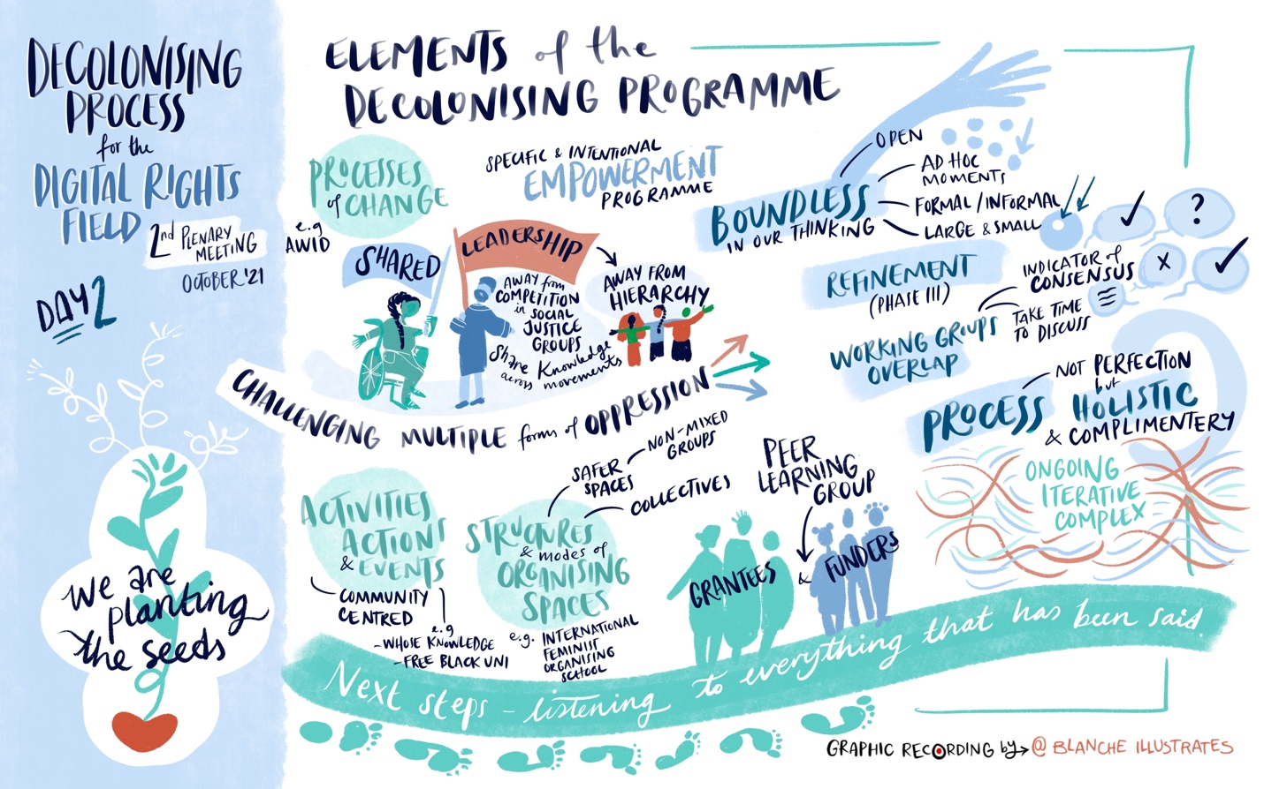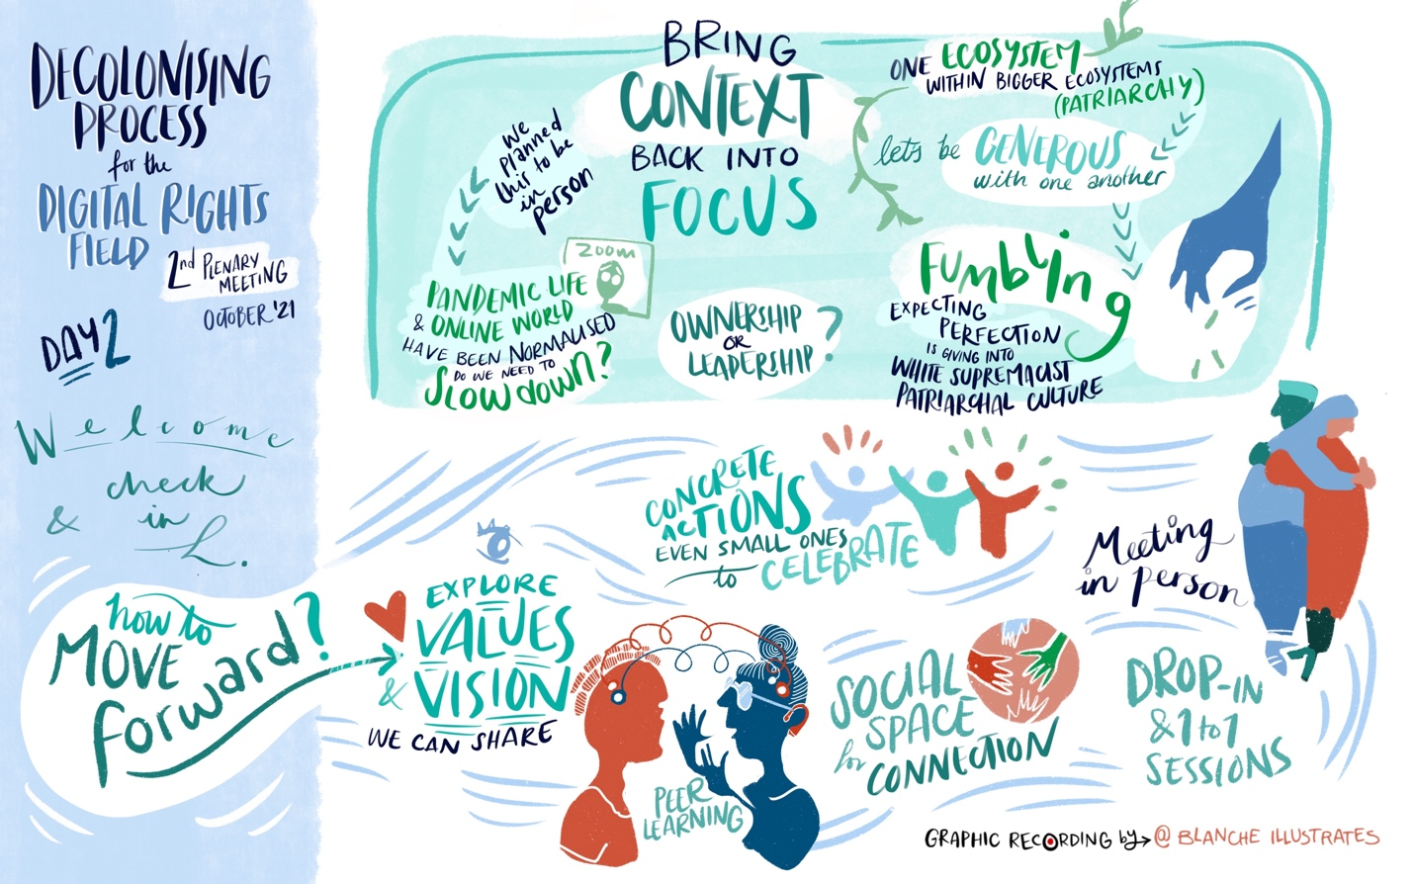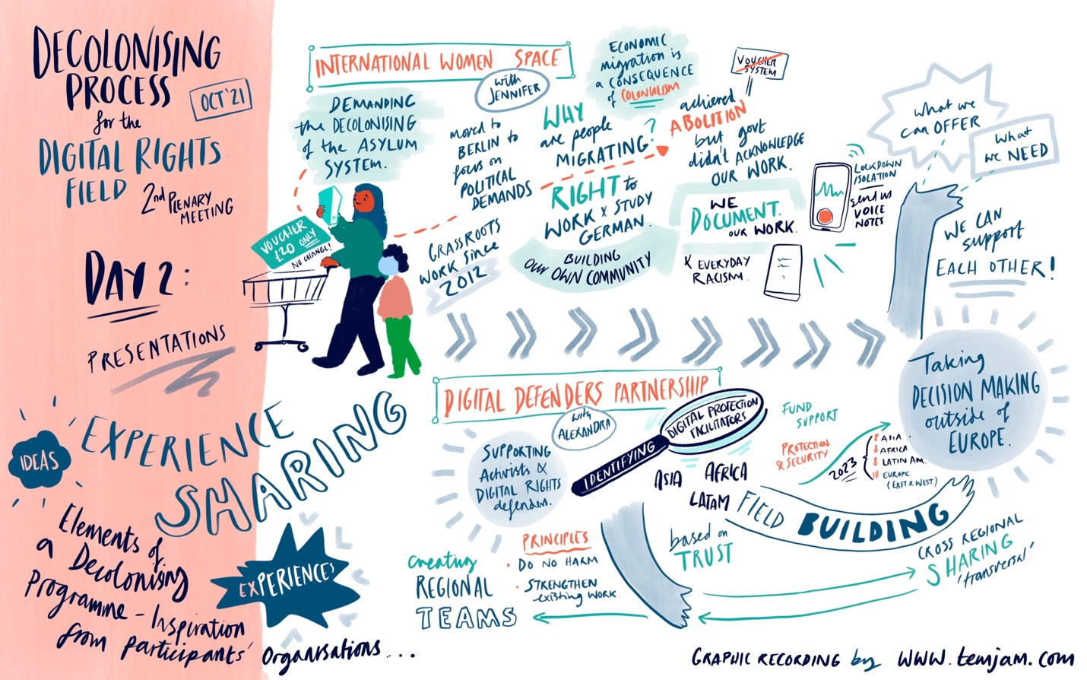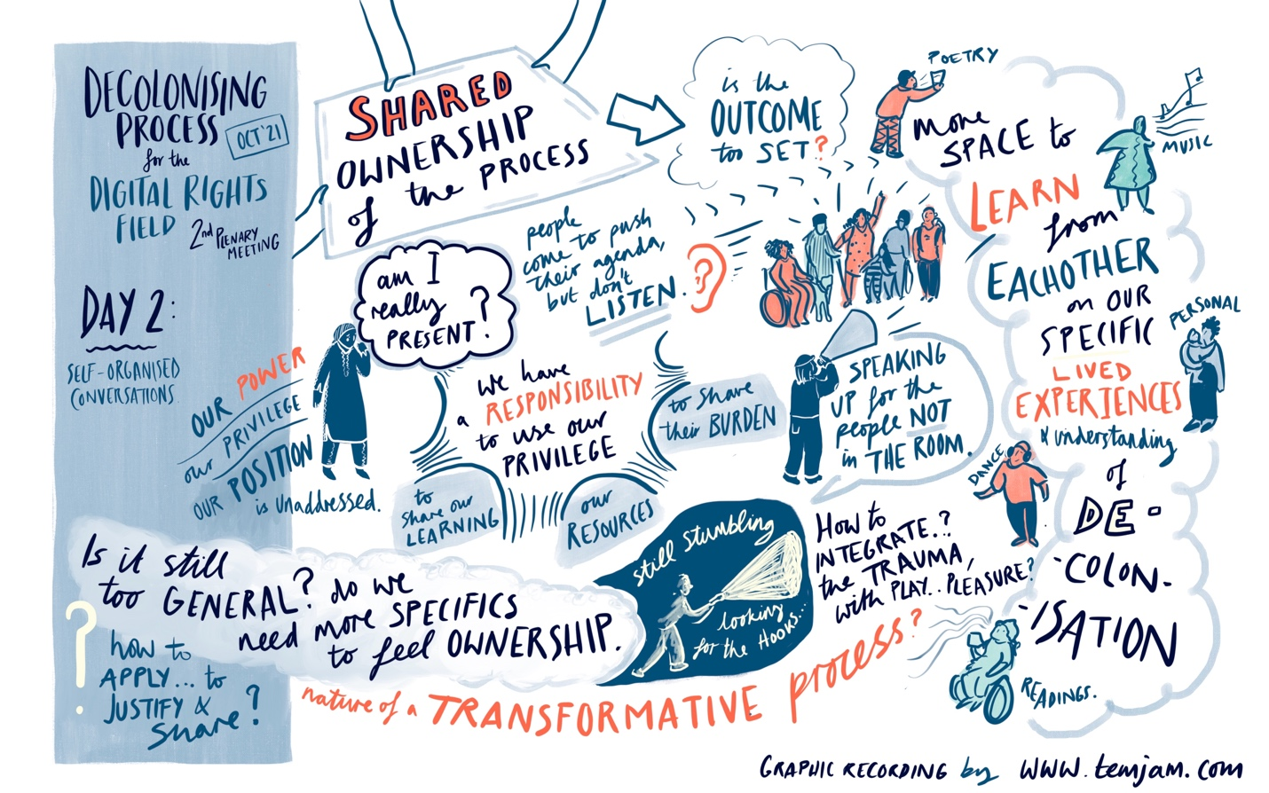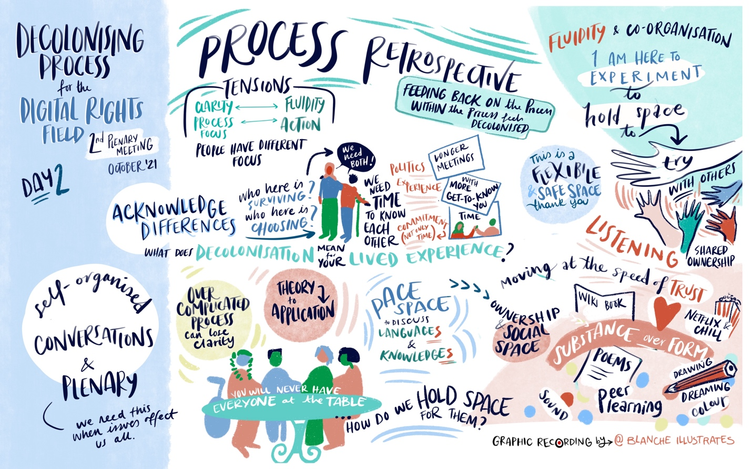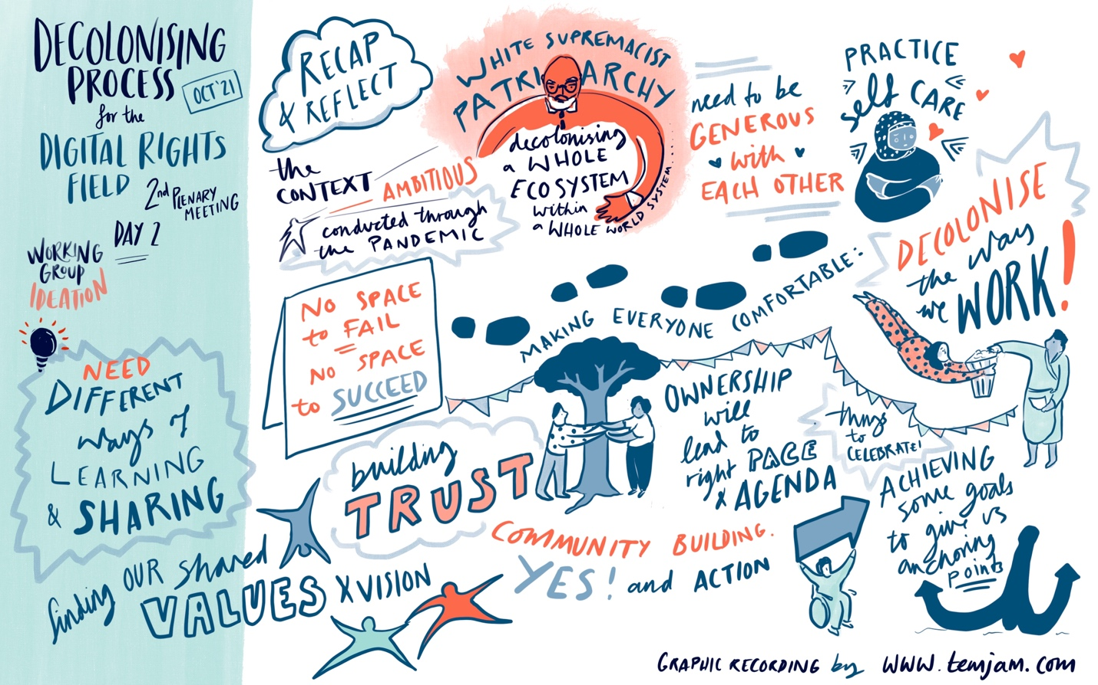
Third Plenary
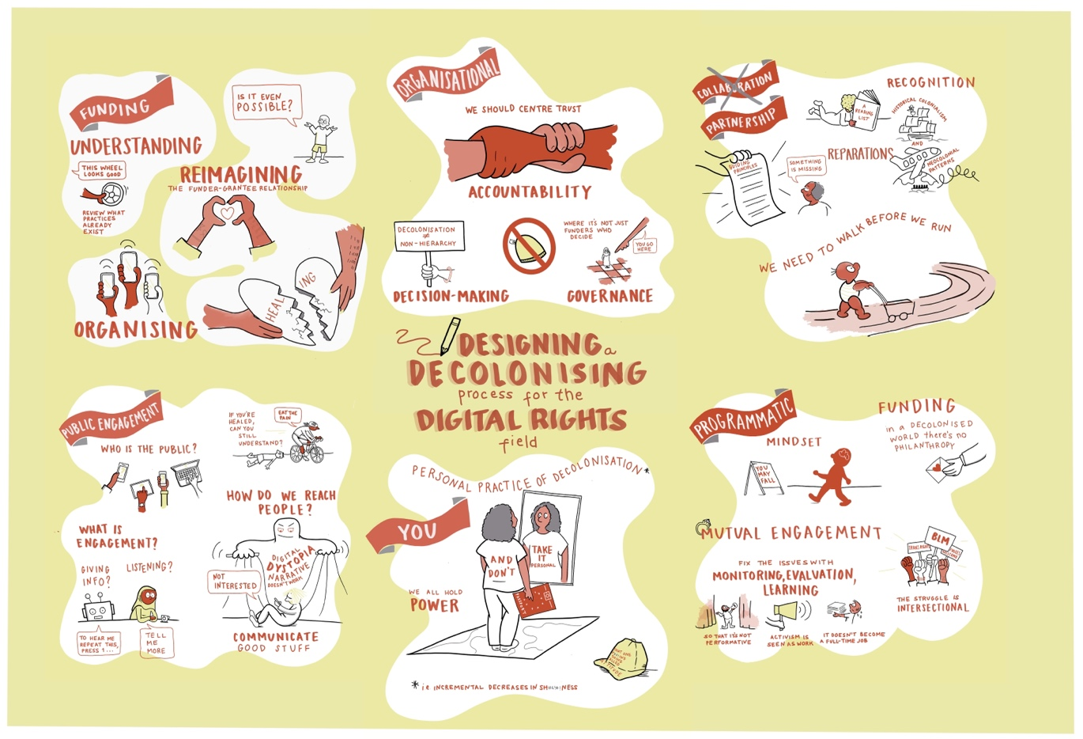
Fourth Plenary

