A vision for digital justice organising in Europe

Contents
Preamble 3
Tending to the digital justice ecosystem: decolonising the existing digital rights field in Europe 4
Imagining, organising, supporting: the elements of a digital justice ecosystem in Europe 6
Weaving Liberation: bringing the digital justice ecosystem to life 11
Grounding Materials 12
References 17
Acknowledgements 18

Preamble

This programme sets out a collective vision for digital justice activism in Europe.

Rooted in the necessity and desire for digital rights work to meet the needs of all in society, particularly those placed at the margins, we imagine a different ecosystem. We imagine a digital rights field that prioritises fighting against the harms experienced by marginalised communities, addresses internal power dynamics and organises in solidarity, an ecosystem that supports and sustains resistance, healing and community by and for those most harshly affected. We imagine a network of racial, social, queer transfeminist, environmental, economic, and tech activists fully equipped to win the fight for digital justice. The ecosystem we imagine is one that will organise towards anti-colonial digital futures.

This programme sets out how we might create and sustain this ecosystem. It is one of several outcomes of a two-year process of collective design with 30 participants from racial and social justice as well as digital rights organisations and funders, hoping to address power dynamics in the field and imagine a vision for anti-colonial digital organising.

The approach of this programme builds on the work of many of those before us and those currently working on decolonising lands, fields, institutions, politics and practices. The majority of them are based in or stem from the global majority outside Europe. We are committed to continuing to learn from and work with these communities of thought leaders, activists, and revolutionaries.

While colonialism, as Europe’s project and creation, is Europe’s responsibility, we acknowledge the limitations of a decolonising work that concentrates first and foremost on Europe. This programme aims to enable more bridging work to happen and rely on the work of diasporas coming from the global South and from people based in the global South. Nonetheless, decolonising will always come from the global South, and an anti-colonial digital justice field in Europe can only aspire so much as to be able to support liberatory movements. When it comes to justice and liberation, we recognise Europe as the margin.

- Laurence Meyer and Sarah Chander

Tending to the digital justice ecosystem: decolonising the existing digital rights field in Europe

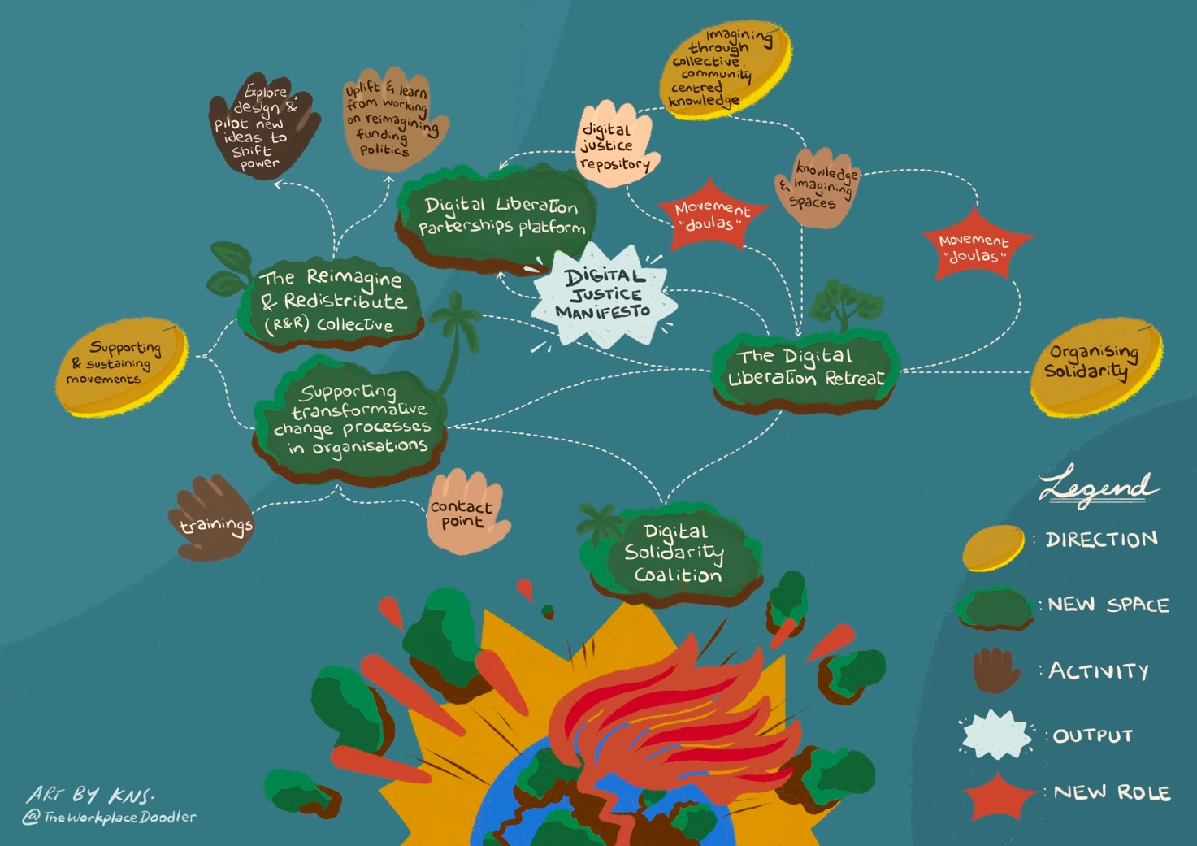

This section explains how the decolonising programme builds on an existing ecosystem of digital rights work in Europe but seeks to radically transform it. The programme aims at this through a range of activities, infrastructures, roles and initiatives. This transformation will take place at two interconnected levels:

- Transforming the structure of the field, including organisations, the dynamics between groups, how funding flows and how and where work takes place, which will lead to;
- Shifting how ideas, agendas, visions, narratives are generated and sustained via the ecosystem’s new spaces, roles, and tools to meaningfully produce justice-oriented agendas, outputs, and outcomes.

The programme proposes to create the necessary infrastructures to strengthen and uplift an ecosystem of activists working towards digital justice from different angles. Many people are already organising on tech issues from a justice and anti-colonial perspective, and there are many activists and/or researchers working against racist digital policing and digital borders, violent digital welfare systems, and tech-enhanced health injustices and labour exploitation. Unions, collectives and forums have flourished in different areas. The programme does not start from scratch but seeks to offer connection points, equitable resourcing and spaces for knowledge production, imagining and organising to ensure that existing and new efforts can thrive. The different elements of the programme are connected and are intended to feed into and nourish each other.

Overview: the digital justice ecosystem

We strive for a digital justice ecosystem that centres on racial, social, transfeminist, economic, and environmental justice activism. This ecosystem will have three key orientations: imagining, organising and supporting. Imagining digital futures, beyond reacting in urgency to the harm we are facing. Organising to make the vision happen by facilitating spaces for organisations to meet, coalitions to be built and movements to strengthen. Supporting organisations and movements to ensure that change is worthwhile and sustainable, first of all for the people making it happen.

We see Knowledge and Imagining spaces where organisations and collectives can challenge harmful technologies and systems and create and share knowledge that serves their resistance and liberatory work. Those spaces will be designed to activate the imagination towards what type of tech realities we want and desire – beyond resisting – spaces where we could explore the question “what if all our tech were life-affirming?”.

The different organisations involved in the Knowledge and Imagining spaces will join the annual Digital Liberation Retreat. We see this retreat as a moment during which people can slow down and reflect on past work, take the time to resource and discuss the challenges they face – on a programmatic level (the type of harms resulting from tech and tech power), an organisational level (salary structure, forms of leadership, transformative management, mental health support, sustainable partnerships etc.) and a movement building level (how the field is resourced and sustained). The retreat will be the place where the imagining, organising, and supporting aspects of the ecosystem come together. From the retreat, new research ideas will flourish, and specific transformative organisational and funding needs will emerge. This picture will be mapped and documented, acting as a basis for new opportunities for partnerships and collective organising, whether for advocacy, campaigning, grassroots organising and/or litigation. This will form the Digital Justice Manifesto.

The new learnings, knowledge, ideas for coalitions, and needs formulated during the retreat will then be shared on the Digital Liberation Partnerships platform to be accessible to a broader set of people, set the start for new Knowledge and Imagining spaces, and inform the support provided for transformative change processes in organisations.

We see the Reimagine & Redistribute collective as a space for critical reflection and propositions around how to equitably resource and sustain the work of the ecosystem. Funders, communities, and organisations will come together to reimagine funding politics and practices. Ideally, funders will be supported to build and make commitments to redistribute capital and shift power. This work will connect to and uplift existing efforts to decolonise funding, and its outputs will feed into the conversations taking place at the Digital Liberation Retreat and hopefully across the ecosystem in terms of how funding flows and work is resourced.

Across the ecosystem, we see Movement Doulas helping to bring life to the objectives of this programme in a number of ways, including conducting outreach to organisations that could be interested in joining the struggle against colonial tech violence both in Europe and beyond and facilitating connections to existing work. We see the Digital Solidarity Coalition as a source of skills, expertise, and resources from technologists and the digital rights field, which could be helpful to wider racial and social justice movements in Europe and across the world.

We see the Digital Liberation Retreat and Digital Liberation Partnerships platform as key spaces for sharing learnings, updates on activities, and key resources that will irrigate and nourish the entire ecosystem.

The elements of this programme will not be realised all at once, and we expect to start with elements related to the Knowledge and Imagining spaces and the Digital Liberation Retreat. It is essential that the programme is owned by the communities it aims to serve; therefore, grants will support organisations that would want to take part in any of the steps it foresees. It is also essential that the programme is not so rigid as to hinder existing work in this space, but instead should open up possibilities, so we imagine that the ecosystem will expand, evolve and change as it finds its own rhythm.

Imagining, organising, supporting: the elements of a digital justice ecosystem in Europe

Here we detail in full the elements forming the digital justice ecosystem, organised in three sections: 1) Imagining through collective, community-centred knowledge; 2) Organising Solidarity; and 3) Supporting and Sustaining Movements. The elements were imagined and developed as part of a two-year collective design process and consultations. More information on this is available in the Grounding Materials section and in the Blueprint to the Decolonising the digital rights field in Europe process .

- Imagining through collective, community-centred knowledge

“If it is true that a revolution can fail even though it be based on perfectly conceived theories, nobody has yet made a successful revolution without a revolutionary theory”.
Amilcar Cabral, The Weapon of Theory, 1966

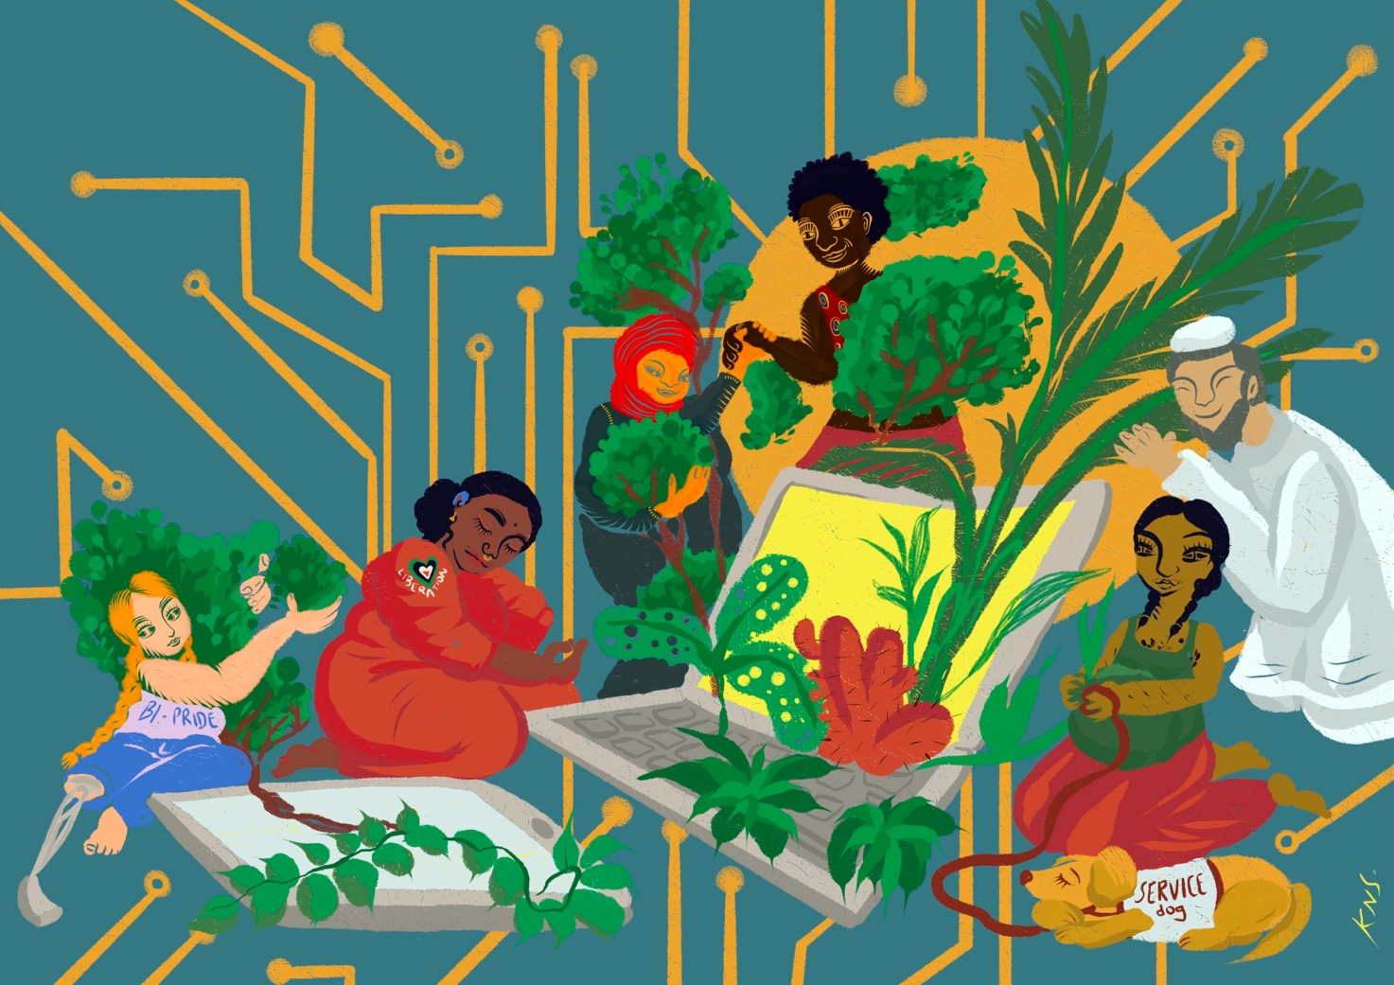

Research is often viewed as an academic tool that doesn't go outside of exclusionary institutions. Reports from non-profit organisations often reproduce how knowledge is developed in academia. How and what we look at, what type of information we need, and how we gain information are not neutral but can reproduce and amplify systems of exclusion. This leads to key issues not being addressed and researched, harms being invisibilised and people affected being perceived as objects of research rather than agents of change. This means that the knowledge necessary for change is either not produced or doesn't circulate where it should.

But we know that for real change to happen, we need to:

- Investigate how colonial dynamics manifest through technological harms.
- Collectively imagine anti-colonial ways to resist and the just worlds we desire.

Without imagination, there is no liberation, and without theory, there is no radical change.

We envisage knowledge production in the ecosystem to happen in two stages: (1) the compilation and amplification of existing work and (2) Knowledge and Imagining spaces to fill the gaps in our understanding of tech harms and support strategising towards the digital futures that serve us all.

1. Compilation and amplification of existing work: We want the knowledge that serves us and has already been produced to be more widely accessible. During the design process, we identified the following preliminary areas of research projects in which compilation and amplification of existing research could start:

- Repository of anti-colonial, abolitionist, and/or transformative movements in tech. Many movements, organisations and researchers are already organising and creating practices and research around digital technologies within anti-colonial, abolitionist and/or transformative frameworks. The repository will aim to amplify their reach and support their archiving. This can help organisations working in policy-making to ground their work in ambitious demands. The repository will not only gather the different sources but also work towards the compensation of the researchers. It will start by mapping critical tech knowledge produced by collectives/researchers from the Global South.

- Mapping of transformative mental health supports available in Europe. Colonial dynamics are, first and foremost, a health crisis impacting our physical and mental health. Specifically for people from marginalised communities, the workplace can often be a space that negatively impacts their mental health, disabling them from doing the work and/or staying in their roles, especially if their role concerns a form of oppression they are directly negatively impacted by. The research aims to map the resources available in Europe that organisations can use to support their employees in a trauma-informed way.

- Understanding the colonial roots of digital rights funding in Europe. We identified that funding practices often reflect colonial dynamics, contributing to the concentration of power amongst mainstream, centralised organisations, avoiding resourcing grassroots, community-centred work and exacerbating imbalances of power aligned with colonial legacies linked to geography, race, gender, sexuality, class, ability, migration status and more. This would explore the colonial and extractivist roots of funders operating in the European digital rights field and presents a series of recommendations on how such funders could provide reparations.

- Framework of indicators for shifting power. We envision the framework to serve as a tool for self-assessment for funders, civil society, and others when implementing activities in this programme or other new initiatives, projects, and partnerships seeking to address and dismantle structural power imbalances. This framework for shifting power will be developed by activists, communities, and collectives working on racial, economic, social, environmental, and digital justice issues. It will be published to facilitate broader reflection on shifting power in other contexts.

- Transformative partnerships framework and mapping of successful transformative partnerships. Recognising that coalition building and relational work are technologies of change, this research will explore how to build meaningful coalitions on social, racial, economic, environmental, and digital justice. This will be a community-driven research and evaluation into how partnerships are formed according to principles of meaningful solidarity. Mapping examples of successful transformative partnership practices as inspiration, the research will produce a community guideline that will serve as a tool and set of reflections for actors looking to build partnerships within and with other movements, particularly in circumstances where there is a power imbalance (for example in terms of access to resources) between the organisations involved.

2. The Knowledge and Imagining spaces will centre on the needs and methods of the communities it aims to serve while creating an interdisciplinary environment. We envision each space to kick-off with a retreat of several days in which groups - for example, Black feminist groups - would gather and have time to discuss how technologies impact them and what type of technologies would serve them as a community of experts. These spaces would allow for conversation between racial, transfeminist, social, economic, digital, and environmental justice organisations, with the support of technologists and academics that are relevant to their thematic of interest. At the end of the workshop, the participants would agree to deepen one theme that they want to gain more knowledge of and set up a working group. These spaces could also centre on a specific theme that lies at the intersection of multiple injustices, such as digital technologies and climate justice and their links to extractivism and displacement.

In thinking of these spaces, we are inspired by the organising tradition of numerous movements and collectives that have fostered community-based knowledge. One digital activism example is the Transfeminist Digital Care Network in Brazil. Since 2021, the Transfeminist Digital Care Network has led the Gincana Monstra, a synchronous and asynchronous online process based on the idea of an infrastructure of affection and the creation of a solidarity network, in eight weeks of exchange and learning about digital and ancestral technologies, strategies and security, territoriality, transcentrality, and intergenerational knowledge, always based on our own experiences, cosmoperceptions, and feelings. The Gincana Monstra is an all-online process to promote learning processes in Digital Care aimed at feminist activists with the intention of being multipliers of this knowledge in their collectives and communities. These convenings enabled a deeper exploration of feminist digital safety methodologies, infrastructures of care, and a stronger network of support for and by feminist facilitators and trainers of digital safety.

- Organising solidarity

"To prepare ourselves to live this other future, to allow ourselves to be moved by what is real, without losing this sense of piety, this sense of conquest, this sense of destiny."

« il est de se préparer à vivre cet avenir autre, il est de se laisser mouvoir par le Réel, sans perdre ce sens de la piété, ce sens de la conquête, ce sens du destin »

Suzanne Césaire, Le grand camouflage, Écrits de dissidence, 1941–1945

A central intention of the decolonising process is to shift power in the digital rights field so that those most affected by technological harm shape the agenda. While communities and people affected are best placed to understand these harms and to organise, we found that social and racial justice organisations were often less resourced to undertake work on digital issues due to broader challenges in access to funding. We also found that there are limited examples of equal, sustainable, transnational organising partnerships. Often, where partnerships do exist, they may display extractive or unequal dynamics. Finally, there are currently very few spaces in Europe in which racial, transfeminist, social, economic, digital, and environmental justice activists, researchers, and organisations can meet to discuss and organise for digital justice.

We envisage new infrastructures for organising and solidarity to ensure that communities primarily affected by technological harm set the agenda of digital justice work and can build solidarity practices amongst those with a shared interest in collective liberation.

The Digital Liberation Retreat. This annual gathering will centre the building of sustainable connections and community building amongst those contesting digital harm. The Digital Liberation Retreat will provide space for collective organising on digital issues from an anti-colonial perspective through workshops, discussions, and skill-sharing on both digital justice priorities and strategies as well as transformative organisational, partnership and funding practices. The retreat will focus on racial, social, transfeminist, economic, and environmental justice organisations. We imagine it as a space to slow down and reflect, connect, and regenerate. As such, healing, joy, and trust-building will be intentionally built in. We imagine a spacious agenda and time to relax and enjoy being together while thinking through heavy and complicated topics. Participants will have the opportunity not only to exchange on thematic points such as tech carceralism, digital austerity, digital feminism, digital labour organising or environmental justice and tech but also to have workshops on organisational structures that foster transformative work and sustainable partnerships and coalitions. The retreat will also offer room to talk about philanthropy and funding more generally. The design of this retreat will prioritise accessibility and care, with the intention of making it a space that feels as safe as possible. This will be a space where different visions and projects of digital justice will have their place and be in dialogue, from a transnational and internationalist perspective.

A Digital Justice Manifesto. One of the main objectives of the Digital Liberation Retreat will be to seek to answer the following questions: how can digital rights serve social, racial, transfeminist, economic, and environmental justice? What are the key issues, struggles, and visions that a digital justice movement should prioritise? How do we organise, resist and create solidarity around those issues in the coming years? Participants at the Digital Liberation Retreat will develop and publish a joint manifesto to outline its positive vision for digital justice. Participants will share their intentions for this vision to avoid co-optation and misuse of the language, terminologies, and ideas. This manifesto will be used to coordinate efforts in policy-making on digital rights issues, engage funders and other stakeholders, and foster coalitions and clarity about the key issues.

Digital Liberation Partnerships platform. We also identified a need for infrastructure beyond gatherings to facilitate connections and solidarity organising between communities and groups. The Partnerships Platform will collate information and facilitate collaboration, participation in future events, and redistribution of resources. It will offer a space for organisations to connect and organise, share information and look for potential new partners on projects etc. It will also work to inform collectives and individuals, especially from outside the traditional digital rights field, to access opportunities for support or collaboration from the existing field, opening up resources, expertise, and solidarity and informing them about the implementation of the activities set out in this decolonising programme.

- Supporting and sustaining movements

“...I refuse to join with them in performing the miracle—I will not say trick—of liberating the oppressed with the gold of the tyrant, and raising the poor with the cash of the rich.”
Dr. B. R. Ambedkar, The Annihilation of Caste, 1936

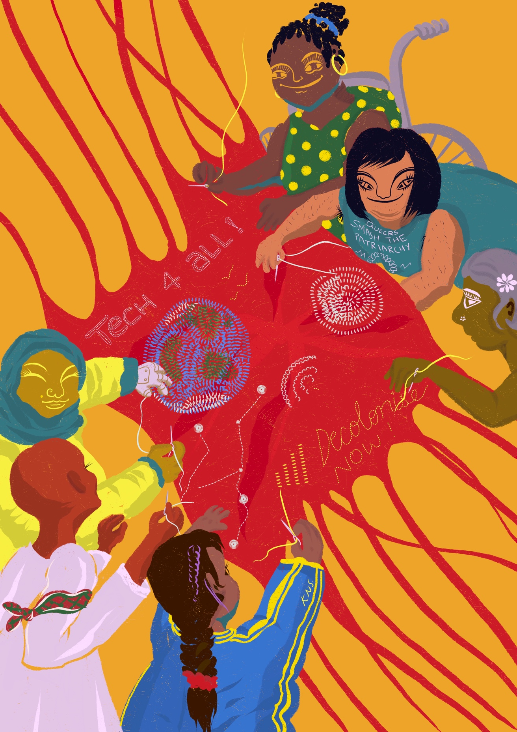

Central to the decolonising process was the need to support and resource the work of contesting digital harms and reimagining other futures. Yet often, this work is significantly under-resourced, with racial and social justice groups, community-led organisations and groups in the global South significantly less likely to access funds for digital justice. Here, funding patterns and practices reinforce a concentration of power within civil society, exacerbating a reality where a narrow, homogenous pool of people are considered ‘experts’ on digital affairs. This shapes the digital rights agenda and structurally excludes critical work on how to mitigate harms to marginalised communities and make systemic change. We envisage the need for structural changes in the way resources are allocated in the ecosystem, new roles to better connect and support movements, and internal decolonising processes in organisations in the field.

The Reimagine and Redistribute (R&R) collective will hold space for funders and community groups to work together to: 1) uplift and learn from work on reimagining funding politics and processes rooted in anti-colonial approaches and 2) explore, design, and pilot new ideas to shift capital and power to resource the self-determined priorities and activities of communities impacted by technology.

We imagine the R&R collective to:

- Advance conversation and commitment to reparative approaches in Europe.
- Uplift and learn from existing initiatives on anti-colonial approaches in funding, including reparations and divestment work.
- Understand the needs of groups impacted by funding processes and decisions with regard to “how funding” happens, to inform the reimagining of:
  - Application process incl. infrastructural support to aid applications (e.g., language support and other types of support etc).
  - Post-funding relationship and dynamics.
  - Learning and impact evaluation that is mutually beneficial and can be practically integrated into future decision making on all ends (for both funders, organisations & movements).
  - Forms of non-monetary support, e.g., network, skills, capacity building, tech and tools.
- Develop strategic approaches to interrogate and transform the composition of funding institutions to be more participatory, relational, and involve meaningful devolution of power to communities.
- Ensure funders prioritise and commit to structural care support for movements, e.g., making specific funds and processes available to support accessibility infrastructure, childcare, healthcare (including mental health support), access to gender-specific services, trauma-informed care support, income support for activists, amongst other things.
- Explore alternative resourcing mechanisms and community-based funding models to help shift dependency away from traditional philanthropy and capital generated by extractive and exploitative means.
- Identify key structural issues in the funding ecosystem and develop strategies to address them through, e.g., campaigns, advocacy, and grantee coalitions.

Funders participating in the R&R will develop and publish a set of community guidelines for how they will commit to decolonial approaches to shifting capital and power by changing funding practices and politics. These guidelines will include explicit guidance on committing funding for structural care support for movements.

We are inspired by the work of funding models including (but not limited to) the Black Feminist Fund, which is changing the way Black feminist groups are supported; the Numun Fund, which is seeding and sustaining feminist technology infrastructures for movement organising in the Larger World; the Emergent Fund, a movement-aligned participatory grantmaker, that resources rapid response and emergent organising led by frontline Black, Indigenous and people of colour; and the Kataly Foundation, which is overspending its funds and houses the Mindfulness and Healing Justice programme, which builds power by redistributing resources to mindfulness and healing justice organisations, networks and practitioners.

Movement Doulas. Our design work highlighted that there is a need for people in the field to help bring life to the objectives of this programme of work. Movement Doulas would play an important role in:
- weaving connections between community-based and digital rights organisations;
- developing and sustaining relationships between groups in the Global South and the Global North, and between groups in the Global South;
- developing new networks/channels for thematic exchange, with a focus on social justice issues rather than technology per se;
- supporting transformative change in organisations; and
- providing critical expertise in healing and wellness for the groups in the ecosystem.

The Movement Doulas are funded positions with specific responsibilities and expertise to help operationalise programme activities. The doulas may also play a role in the overall collective governance of this programme of work. We are inspired by the disability justice movement and creative practitioners’ work on the role of access doulas, people who monitor and assist with participants’ active needs in different spaces.

We intentionally use the term Doula, with its gendered meaning, to highlight the central, birthing, nourishing, and nurturing role that women and non-binary people have specifically played in digital justice, in particular their role in creating and sustaining movement.

Digital Solidarity Coalition. Throughout the process, we reflected that existing digital organisations are potentially a source of great skills, expertise and resources that could be helpful to wider racial and social justice movements, in Europe and across the world, if there were greater connections and if more work happened in solidarity. To facilitate practices of solidarity amongst organisations working on digital issues, we envisaged the Digital Solidarity Coalition as a group of individuals and organisations with technical, digital, operational and legal skills to organise and offer meaningful and tangible support to racial and social justice movements. This could include:
- skill-sharing workshops on issues co-defined with racial and social justice organisations;
- long-term support with technical infrastructure; and
- support with access to resources and finance, including fundraising with, and for such movements.

These activities and resources will be published on the Digital Liberation Partnerships Platform, and the support offered could include building and maintaining that online platform.

Supporting transformative change processes in organisations. Support in the form of training and peer-support spaces, and a contact point for transformative organisational practices, will be available to organisations. If organisations in the field are not safe for members of marginalised groups or are unable to be trusted partners to community-based organisations, the field will not be able to effectively contest technological harms. More generally, all organisations working at the intersection of justice and tech can benefit from support to make their organisational structure sustainable. Only sustainable organisations with strong anti-oppressive and transformative practices can work towards durable structural anti-colonial changes. This support will primarily centre the needs of racial, social, and economic justice organisations working on digital issues, but would be beneficial for all organisations committed to transformative change. To encourage and support tailored internal transformative processes in organisations, we envision:

- a series of training and peer-support spaces, including conversations on: governance and leadership, HR policies, accountability infrastructures, sharing power, decision making and consensus building, communities of practices, healing, reparations, and health;
- a central contact point for advice on building internal transformative change and decolonising processes.
- materials to support the internal transformative processes of organisations, including groups of experts, reading lists and other material on transformative and organisational change. This will also include the necessary resources for digital organisations on (a) how to transform their own organisations to create the capacity to work in solidarity with racial, social, economic and environmental justice movements and (b) encourage more engagement of critical technologists in racial and social justice movements.

To work towards transformative organising, we are inspired by the work of the disability justice movements and the 10 principles of disability justice that can be found on the Sins Valid website, the Black feminist organising in Latin America and the Caribbean research, the landless workers in Brazil and their organisational practices and knowledge, the organisational practices of Whose Knowledge? and the beautiful “Strategies for building an organisation with a soul” by Hope and Rudo Chigudu.

Weaving Liberation: bringing the digital justice ecosystem to life

The coordination and implementation of the programme requires a certain level of centralisation to ensure its coordination and accountability, although its implementation is foreseen to be decentralised in its main parts.

Following consultation with the existing participants of the programme, this coordination role will shift towards a new collective structure better suited to support the realisation of this programme. This structure will work to reinforce and sustain a strong digital justice ecosystem in Europe.

The new structure, called ‘Weaving Liberation’, will take the initial form of a collective space with the function of implementing the decolonising programme. It will co-create and provide support to organisations interested in implementing parts of the programme and ensure the coordination of its monitoring. The broader goal of this space will be to support transformative work on digital justice and liberation in Europe by connecting movements to work towards structural change. This new structure will coordinate the Digital Liberation retreat and the doulas and resource organisations who would like to participate in implementing the programme through a participatory form of grant-making. In the longer term, we envision ‘Weaving Liberation’ to also resource more generally work on digital justice.

Grounding Materials

This document is the product of a two-year process of collective design with 30 participants from racial and social justice, digital rights, and funders, aiming to address power dynamics in the field and imagine a vision for anti-colonial digital futures. This was a process led and facilitated by the Digital Freedom Fund and European Digital Rights, which organised and held funds for the design phase.

As such, a lot of work has underpinned this process, and there is quite some material that grounds it, by way of documentation of the process, analysis of the core problems, and the frameworks and praxis that we were influenced by. This section provides more information about this grounding material for those interested to know more.

Why are we doing this work?

The Decolonising the Digital Rights field in Europe process sought to address the limitations of the current European digital rights field that leave it unequipped to tackle the many digital harms we face.

Digitalisation takes colonial forms in the shape of:
- increased extraction of resources from land, environment, and people;
- deeper and more invasive levels of policing, surveillance, and discrimination;
- concentrated power and decision making over central infrastructures owned by Big Tech,
- wide-scale inequality in terms of access to resources.

We see these dynamics as a direct part and parcel of broader systems rooted in capitalism, white supremacy, patriarchy, imperialism, and settler colonialism.

The digital rights field in Europe is in its current form under-equipped to resist these harms. It currently suffers from a general silo-ing from broader struggles for justice. The communities most harmed by digital technologies are underrepresented in digital rights organisations (particularly from racialised, migrant, disabled, precarious working, queer and trans, global South and working class communities). The current functioning leads to a narrow framing and conception of digital rights as well as exploitative, extractive working and resourcing patterns. To effectively be in the capacity to resist, this needs to change.

How do we understand decolonising?

This process intentionally used the term decolonising to reflect that present technology-powered injustices and oppression have their roots in a history of domination and colonisation and are maintained by structural forces. We use the term decolonising to reflect that the work of dismantling and repairing colonial harms is an ongoing process and not an end in itself. We are focusing on structural changes and divesting from approaches making mere 'tweaks' to existing systems that fail to achieve justice for all.

We recognise that decolonising points to both these processes of decolonising in fields, disciplines and spaces, but also to the very material reality of land justice and the need for reparations. The ecosystem we aspire to create is one in which digital topics are understood as intimately connected to the material world- as ones which exacerbate the processes of extractivism, theft, and ongoing harm to indigenous people, displaced people, and the planet.

When we talk about histories of domination and colonisation, we mean the different ways in which supremacy manifested in different geographical spaces through time. Learned terminologies that are deeply ingrained in our senses of self and social belonging can be a barrier to a more holistic understanding of the core mechanics fostering inequality and injustice across our European societies. While some European nations were capital C colonisers and others were not, it is undeniable that Europe as a continent benefited from colonisation as a whole – from profits to the construction of whiteness off of the oppression and violence exerted against non-Europeans This does not negate the reality of power imbalances within the continent, especially between the West and East.

Concretely, Eastern Europe being impoverished through labour and resource exploitation by the West and other imperial powers is a history of domination and colonisation fostering present-day structural oppression. At the same time, the enslavement and extermination of racialised communities in Eastern Europe is also a history of domination and colonisation that fosters present-day structural oppression.
The decolonising framework is less preoccupied with discerning between the differently named political manifestations of dominance across the continent – especially when used to detract from the substance of the matter – and more invested in addressing all forms of structural violence, harm, injustice and oppression, in order to enable liberation for all.

We also consider decolonising to be a process of shifting power and building other worlds. As such, the content of this programme builds on many legacies of Black, feminist, global South and radical world-making ideologies. We believe that central to shifting power are the elements of healing and reparations, imagining, transforming, changing, and fundamentally, the redistribution of resources. These are the baselines we measured our programme against.

- By healing and reparations, we mean that all decolonising processes must engage with clear material and symbolic reparations towards the communities and lands that have historically been stolen (from) and exploited by colonial dynamics. It also recognises that colonialism and coloniality produce trauma and untimely death and that all anti-colonial practices must therefore centre on healing to transgress this violent framework. Finally, this means considering divesting from harmful practices as an essential element of the work.
- By imagining, transforming, and changing, we mean that colonisation killed many worlds, and the possibility of remembering and/or imagining them. Decolonising, therefore, necessarily means imagining entry points into new worlds outside the current status quo by testing and failing and daring again and re-adjusting delicately and/or suddenly.
- By redistribution of resources, we mean that colonisation produced a structural unequal access to vital resources and a destructive relationship with sentient and inanimate beings. Decolonising means creating the conditions for fair and life-affirming access to resources for all by drastically changing how resources are accessed and who decides.

We use the term “transformative” frequently. By that, we mean processes in capacity to challenge the status quo and create, amplify, and/or better alternative spaces and practices, rendering the current oppressive realities obsolete.

We attempted to find indicators for shifting power to guide us in the move to radically change power dynamics. Some initial indicators identified were:

- shift in decision-making roles towards structures of shared power (in accountability, pay structure, representation etc.);
- recognition and compensation of emotional and care labour and the added burden of transformative work on members of marginalised communities;
- collective processes regarding the allocation of resources power as to where funding goes and for what;
- existence of structures of accountability to prevent and repair structural oppressions;
- existence of processes to ensure that work is community powered and centred (centring lived experience and community expertise);
- commitment to processes to build power separately from oppressive institutions.

There are likely to be many more indicators of the shifting of power, and as such, a more complete framework of shifting power is one of the proposed elements in the programme.

What is the scope of the programme?

The scope of this programme is intentional in its focus on digital activism in Europe. The roots of colonialism are in Europe, and as such, it is our role to tackle Europe’s historic and ongoing role in perpetrating colonialism, to prevent future harm, and to press for accountability and repair for harm done in the past. The ongoing effects of colonialism show up in digital harms and digital rights work need to be addressed here to mitigate the effects of ongoing dominance in digital rights work elsewhere. We nonetheless recognising that decolonising has always been rooted in the Global South. Therefore, the work will live in the following tension: although it ought to be the focus in Europe, Europe is never the centre regarding anti-colonial emancipation.

We believe that dismantling colonial dynamics in the European digital rights space will contribute to and sit alongside processes of decolonisation elsewhere. But for this to happen, this programme seeks to maintain a balance of dismantling imbalances of power at the root, in Europe, but also seeking greater connection, redistributing and being led by digital activism happening in the Global South and marginalised communities everywhere. We hope that these changes can contribute to meaningful practices of solidarity in action, ongoing reparation processes, and a more just distribution of resources in the global digital justice movement.

Decolonising is neither a one-time event nor can it be done in one field in isolation. However, we believe that decolonising can and should take as many shapes as possible, as long as it centres on redistribution of resources, reparation of colonial harms and land back.

We know that this programme and its ability to fully realise itself as we have imagined it will depend on resourcing and where people engage. There will be a need to prioritise how and where funds are spent. The participatory nature of those decision-making processes will be key in ensuring accountability to communities, collectives, and wider actors in the ecosystem.

Who is this programme for and how do we engage?

We see this programme as an offering and an invitation to anyone committed to building anti-colonial digital justice activism. We hope it will resonate with collectives, organisations and individuals and that they will engage by implementing aspects of the work.

In particular, we intend for this programme to facilitate digital justice work led and centred on marginalised communities, particularly racialised, queer and trans, the global South, disabled communities and precarious workers, including those in sex, care and platform work.

As such, we invite those who wish to undertake related, connected work to do so and to connect with aspects of this ecosystem where there are overlaps or synergies.

Much of this will come to life in practice. This work is the product of collective design, constant change, and iteration. As new people engage with this work and our community grows, we expect these ideas to shift, advance, and grow.

How has this work happened to date?

In March 2020, the Digital Freedom Fund (DFF) and European Digital Rights (EDRi) embarked on a multi-year process aimed at bringing together communities negatively impacted by digital harms but structurally excluded from the current digital rights field in Europe, with existing digital rights actors and organisations that fund digital rights work. The objective of this process was to collectively design a decolonising programme that would radically transform the European digital rights field.

While the collective drafting of the programme was always a central element of this work, the coordination team believed that the process was as important as the output. As a result, the process was designed to be iterative and flexible, intentionally departing from ‘business as usual’ and making a clear break with ways of being, working and producing that reinforce lineages of oppression.

The Decolonising Design process operated with a series of roles, including process facilitators (organisers – DFF and EDRi), core participants, and artistic support and advisors. Much of the work was conducted through five working groups, which the participants were divided into (with 5-7 participants in each). Each working group focused on a particular aspect of how the digital rights field organised its work: programmatic, funding, public engagement, collaboration and organisational. These groups were chosen because of input and initial desk research from the scoping phase.

Our process occurred in phases:

  - Phase I: Scoping Phase: The first phase of the process dealt with the original idea and scoping and was meant to flesh out the premises of the project together with relevant stakeholders. This lasted for one year.

  - Phase II: Collective Design Phase: The second phase of the process was the collective design phase of the decolonising programme, which lasted just over two years.

  - Phase II: Implementation and Transition Phase: The third and final phase of the process is upcoming. It will aim to focus on the implementation of the programme and the transition towards a sustainable way of organising in order to carry this process through to the future.

A blueprint documenting how the process was designed, how it went, and learnings from it- thought as a how-to-guide- is available here: weavingliberation.org

Next steps and transition

Until now, this was a process led and facilitated by the Digital Freedom Fund and European Digital Rights, who organised and held funds for the design phase. While we acknowledge that EDRi and DFF want to be involved in the programme implementation, these organisations are very different in nature, and considering their power and position in the field, they may not be the best placed to lead this process in the long run. We know organisations that have a long tradition and extended knowledge and practices of anti-colonial, antiracist, queer, transfeminist and anticapitalist organisational work are the ones who are best placed to take it further.

After the launch of this programme in November 2023, we will begin a transition of the coordination of this work to a more collective, community-centred structure that is more equipped to embed and implement the value of this work. We call this structure ‘Weaving Liberation’.

Beyond the release of this programme, Weaving Liberation begins to take form and moves into the role of tending the ecosystem to help bring about the new initiatives, spaces and activities set out in this programme. Our hope is that the fruits of this collective design process can continue to engage more communities and organisations, especially those most affected by digital discrimination, surveillance and extraction.

References

Much of our process was shaped by the leaders of our peer-learning sessions:

- Trauma-Informed Organising, led by Lorraine Maher and Uwayo Dushime

- Abolitionist Technology and Visions from the Global South, led by Chenai Chair, Imani Mason Jordan, and Thenmozhi Soundararajan

- Decolonial Practices and Decolonial Leadership, led by Anasuya Sengupta and Coumba Touré

- The Revolution Will Not be Funded, led by Renee Hatcher and Mukasa.

Our influences and inspirations for this draft programme are wide and many. Below we detail just some of the rich resources we drew on throughout the process.

J. Khadijah Abdurahmanm, “A body of work that cannot be ignored” (2021) Logic Magazine, Beacons Issue.

Shay Akil McLean, “Decolonization: What Ought To Be”, Decolonize All The Things

Kaswar Ali, “the logics of digitisation: race, cyberspace and digital settler colonialism”, (2021) Journal of Global Indigeneity

Pollicy, “Automated Imperialism, expansionist dreams (digital extractivism)”

Myriam Aouragh, Seda Gürses, Helen Pritchard, Femke Snelting, “The extractive infrastructures of contact tracing apps” (2020) Journal of Environmental Media

Irmgard Emmelhainz, “Decolonization as the horizon of political action”, e-flux

AI Decolonial Manyfesto: https://manyfesto.ai/

Seeta Pena Ganghadharan and Jędrzej Niklas, “Decentering technology in discourse on discrimination” (2019) Information, Communication & Society

bell hooks, Teaching to Transgress: Education as the Practice of Freedom (1994)

Eric Ritskes, “What is decolonization and why does it matter?”, Intercontinental Cry (2012)

Community Defense: Sarah T. Hamid on Abolishing Carceral Technologies – Logic Magazine

Tuck, Eve, and K. Wayne Yang. “Decolonization Is Not a Metaphor”. Decolonization: Indigeneity, Education & Society 1, no. 1 (8 September 2012).

Whose Knowledge et al., “Our Stories, Our Knowledges: The full series” (2018)

INCITE! Women of Color Against Violence, The Revolution Will Not be Funded (2017)

Black Feminist Fund, “Where is the Money for Black Feminist Movements" (2023)

Astrae, “Technologies for liberation, towards abolitionist futures”

Hope Chigudu, Rudo Chigudu, “Strategies for Building an Organization with a Soul”

Sénamé Koffi, African smart cities in 2030, the journal of field actions

Amilcar Cabral, The Weapon of Theory (1966)

Curseur, Smartphones ! Le coût du confort.

Ruha Benjamin, Race After Technology: Abolitionist Tools for the New Jim Code (2020)

Acknowledgements

The participants who designed this programme are:

Alejandro Moledo (European Disability Forum)
Alexandra (Digital Defenders Partnership)
Ali Khan (Open Society Foundations)
Alyna C. Smith (Platform for International Cooperation on Undocumented Migrants)
Arthur Steiner
Asja Lazarević
Anasuya Sengupta (Whose Knowledge?)
Anna-Dorothea Grass (Bosch Stiftung)
Asli Telli (Alternatif Bilisim)
Azar (Kvir arhiv)
Carine Marzin (European Disability Forum)
Chenai Chair
Chris Jones (Statewatch)
Cianán Russell
Danilo Krivokapić (Share Foundation)
Eleftherios Chelioudakis (Homo Digitalis)
Esra Özkan (Justice, Equity and Technology Table)
Gabriela de Oliveira (Glitch)
Inés Binder (Digital Defenders Partnerships)
Jennifer Kamau (International Women* Space)
Juliana Wahlgren (European Anti-Poverty Network)
Luca Stevenson (European Sex Workers Alliance)
Mukasa (International Trans Fund)
Myriam Douo
Nadia Benaissa (Bits of Freedom)
Nakeema Stefflbauer (Frauenloop)
Raegan MacDonald
Roxanna-Lorraine Witt (save space e.V.)
Salmana Ahmed
Temi Lasade Anderson
Vidushi Marda
Willem Lenders

A special thank you to Nani Jansen Reventlow, who ideated and initiated the Decolonising the Digital Rights in Europe work over two years ago and has been instrumental to the process and the final programme.

A first draft of this programme was drafted by Sarah Chander and Laurence Meyer who co-led the Decolonising the digital rights field in Europe process.

This final programme was drafted by Laurence Meyer, Salmana Ahmed and Sarah Chander, and reviewed by Ioana Barbulescu and Joel Hide. Claire Fernandez and Mauricio Lazala, as directors of European Digital Rights (EDRi)* and the Digital Freedom Fund respectively, contributed to this draft.
This document is the product of a detailed consultation between April and May in 2023, through which a wider community participated in the building of this document. The consultation process was led by Salmana Ahmed with input from Laurence Meyer and Sarah Chander and support from Joel Hide and Ioana Barbulescu.

The text of the programme was proofread by Denzel Russell. It was translated into Arabic, French, Portuguese, Romani, Serbian, and Spanish by Hend, Eden Tinto Collins, Hannah Bastos, Alen Umer, Asja Lazarević, and Blanca Sánchez Rangil respectively. The Arabic version was edited by Rokaya Selim.

We are immensely grateful to the people who took time to share their valuable feedback which has informed this redraft of the programme, which includes:

  - Alba Hernández
  - Aldessa Georgiana
  - Bonnita Nyamwire
  - Carmen Gheorghe
  - Coumba Toure
  - Danny Spitzberg
  - Femke Smelting
  - Hakima Abbas
  - Julia Kloiber
  - Kim Tran
  - Kwamou Eva Feukeu
  - Louise Hickman
  - Luis Fernando Arias
  - Madhuri Karak
  - Malak Elhamidy
  - Martina Fin
  - Mher Hakyoban
  - Nadia Asri
  - Omar Jabary
  - Onai Hara
  - Oyidiya Oji Palino
  - Paz Peña
  - Petra Molner
  - Soledad Magnone
  - Tarcízio Silva
  - Willem Lenders
  - TALAY’AN
  - EDRi members*

*Although European Digital Rights co-led the Decolonising the Digital Rights field in Europe process, this programme is not an official position of the EDRi network.

***

“The past cannot be forgotten but we can redistribute the burden of carrying it. Reconciliation of the main actors in the digital rights field and the main targets of societal discrimination is imperative. That means admitting the wrongdoings, be honest with each other and see if it is at all possible. Sometimes it is not. Capital is what´s yours, not hers. Majuscule. Start of a sentence, the first word. But not the last. We know the empire of white supremacy is the biggest thing to tackle. We know borders will always separate, the question is: who is going to be trapped. What madness to think we can stop people from climbing over walls with barbed wire when the violence we caused is the reason they attempt to climb on them. Am I stuck in this system? Never! Like my ancestors and your ancestors before you, I shall fight! It will take a lot to make the sun rise, to be comforted with the embrace of warmth on your skin, like a grandmother comforts her grandchild who knows what it is to fight, to resist, to be in pain, to recover, to return in a stranger form, transforming into a rooted tree. Roots and family tree are the roots of a tree and how deep down and old they are is also how long our generations have lived on earth. Find the roots of your fears and search within you and your past. Let´s remove all the sharp edges between us. Maybe they would give us pleasure, solace, take my mother to the forest, destroy capitalism, calculate freedom, feed our children honey when they get sick. Our smile like barbed wire, shiny and dangerous. They stood in the hallway with cut lips and bruises, staring at each other. They couldn’t remember who raised their fists first.”

Decolonising the digital rights field in Europe- collective writing manifesto, Essaouira, December 2022

For more information about the decolonising process and people that generated this programme, the works that inspired us or the frameworks underlying this work, visit the Grounding Materials section and/or consult the Blueprint on www.weavingliberation.org
The word "doula" comes from ancient Greek, meaning "a woman who serves" or “female caregiver”. The term and practice have since developed and are now used to refer to non-clinical birth workers who are trained to provide physical, emotional, and informational support to pregnant people in the prenatal, birth, and postpartum periods. Doulas are commonly placed in the context of community-based practices of healthcare and support. The programmatic working group used the term doulas to refer to individuals or groups who provide support to the movement to grow and develop, particularly at intersections of digital and social justice.
However, we note the tensions arising from using this term: links with the automatic feminisation of labour, the structural undervaluing of (social) reproduction, care and support work. We use this term to reject, reclaim, and place value on this work.

